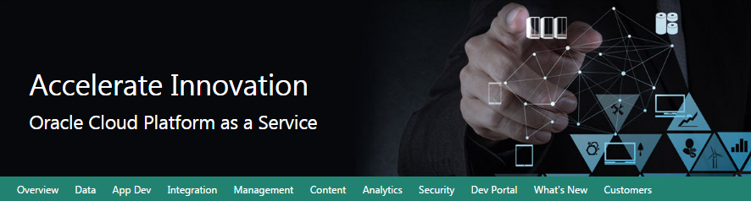

Oracle Data Management Cloud Workshop

Database Cloud Service

Updated: July 6, 2017



**Safe Harbor Statement**

The following is intended to outline our general product direction. It is intended for information purposes only, and may not be incorporated into any contract. It is not a commitment to deliver any material, code, or functionality, and should not be relied upon in making purchasing decisions.

The development, release, and timing of any features or functionality described for Oracle’s products remains at the sole discretion of Oracle.

**Oracle Training Materials – Usage Agreement**

Use of this Site (“Site”) or Materials constitutes agreement with the following terms and conditions:

1. Oracle Corporation (“Oracle”) is pleased to allow its business partner (“Partner”) to download and copy the information, documents, and the online training courses (collectively, “Materials") found on this Site. The use of the Materials is restricted to the non-commercial, internal training of the Partner’s employees only. The Materials may not be used for training, promotion, or sales to customers or other partners or third parties.

2. All the Materials are trademarks of Oracle and are proprietary information of Oracle. Partner or other third party at no time has any right to resell, redistribute or create derivative works from the Materials.

3. Oracle disclaims any warranties or representations as to the accuracy or completeness of any Materials.  Materials are provided "as is" without warranty of any kind, either express or implied, including without limitation warranties of merchantability, fitness for a particular purpose, and non-infringement.

4. Under no circumstances shall Oracle or the Oracle Authorized Delivery Partner be liable for any loss, damage, liability or expense incurred or suffered which is claimed to have resulted from use of this Site of Materials. As a condition of use of the Materials, Partner agrees to indemnify Oracle from and against any and all actions, claims, losses, damages, liabilities and expenses (including reasonable attorneys' fees) arising out of Partner’s use of the Materials.

5. Reference materials including but not limited to those identified in the Boot Camp manifest cannot be redistributed in any format without Oracle written consent.

Contents

Section 1: Database Cloud Service Overview 4

1.1: Introduction 4

1.2: Objectives 4

1.3: Lab Requirements 4

1.4: Retrieve Public IP for Client Image 5

1.5: Create Database Cloud Service Instance 13

1.6: Configuration and Image Exploration 25

Section 2: Cloud Migration 41

2.1: Introduction 41

2.2: Objectives 41

2.3: System Requirements 41

2.4: Cloud Migration Using Pluggable Databases 41

2.5: Cloud Migration Using Data Pump 65

2.6: Cloud Migration Using SQL Developer Carts 79

Section 3: Backup and Recovery 88

3.1: Introduction 88

3.2: Objectives 88

3.3: Lab Requirements 88

3.4: Oracle Public Cloud Backup Recovery 88

Section 4: Database Development 101

4.1: Introduction 101

4.2: Objectives 101

4.3: Lab Requirements 101

4.4: Alpha Office and APEX 101

# Database Cloud Service Overview

### Introduction

This lab will help give you a basic understanding of the Oracle Database Cloud Service and it’s capabilities around administration and database development.

We will walk through creating a new Database Cloud Service instance. After the database has been created, you will connect into the Database image using an SSH private key and familiarize yourself with the image layout. Next you will learn about SSH tunneling using an SSH configuration file. This file will be used to tunnel multiple ports to a remote OPC instance. Using the tunnels, you will learn how to access various Database consoles.

### Objectives

* Create Database Cloud Service
* Configure security with SSH
* Explore VM and cloud consoles

### Lab Requirements

* VNC Viewer to connect to an Image running on Oracle’s IaaS Compute Service.
* Laptop capable of connecting to the internet and running VNC Viewer
* Cloud environment access details provided by instructor in advance of the class

**Note:** *Use the table below and fill in the blanks as you go through the labs. Create a text file or note on your VNC desktop to keep track of important information you’ll need throughout the lab exercises so that you can easily copy and paste the information.*

|  |  |
| --- | --- |
| Cloud Data Center: |  |
| Identity Domain: |  |
| Login Username (s): |  |
| Login Password: |  |
| Alpha01A-DBCS Cloud Public IP Address: |  |
| Alpha01A-DBCS Cloud Private IP Address: |  |
| Site Location ID: |  |
| Alpha01B-DBCS Cloud Public IP Address: |  |
| Alpha01B-DBCS Cloud Private IP Address: |  |
| Client Public IP Address: |  |
| Client Private IP Address: |  |
| VNC Viewer Port #: |  |
| Client Image VNC Viewer Password: |  |

### Retrieve Public IP for Client Image

For the Database Cloud Service Workshop we will be using a Client Image running in the Oracle Compute cloud to simulate the on premise environment. This client image is running Linux and contains a preinstalled Oracle 12.1.0.2 database with a pluggable database that we will migrate to the Oracle Public Cloud Database instance. The client image contains SQL Developer 4.1, SQL*Plus and other utilities that will be used to connect and manipulate both the local and cloud database instances.

The Client Image is a VM that is running on Oracle’s IaaS Compute service.

#### Retrieve Public IP for Client Image

* Login to your Oracle Cloud account
* Open a browser and go to the following URL: https://cloud.oracle.com
* Click Sign In in the upper right hand corner of the browser

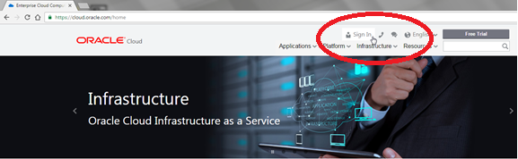

* Under My Services > Select Data Center … select the region from the drop down list. Your instructor will provide this information to you prior the course. 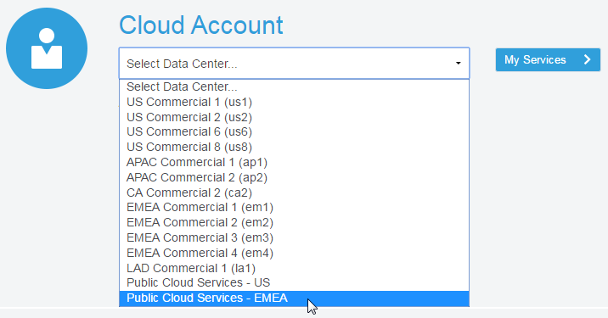
* Enter the identity domain and click Go

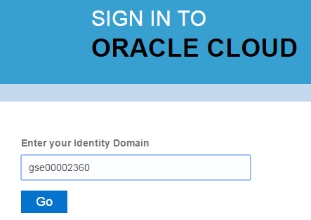

* After entering the Identity Domain you will enter the User Name and Password
* Click Sign In

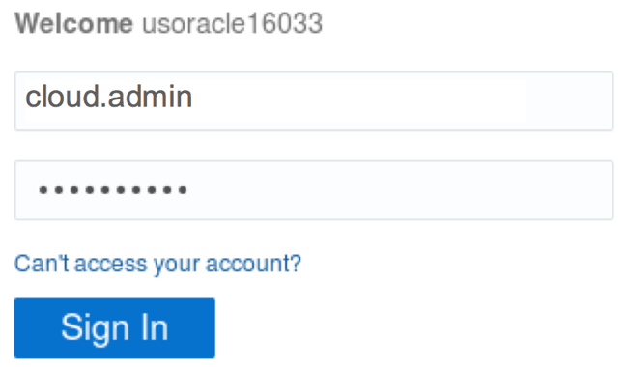

**NOTE**: The Identity Domain, User Name and Password values were provided to you by your instructor prior to starting this lab.

* You should see the Dashboard summarizing all of your available services. Compute, backup, and storage are all related to the Database Cloud Service.

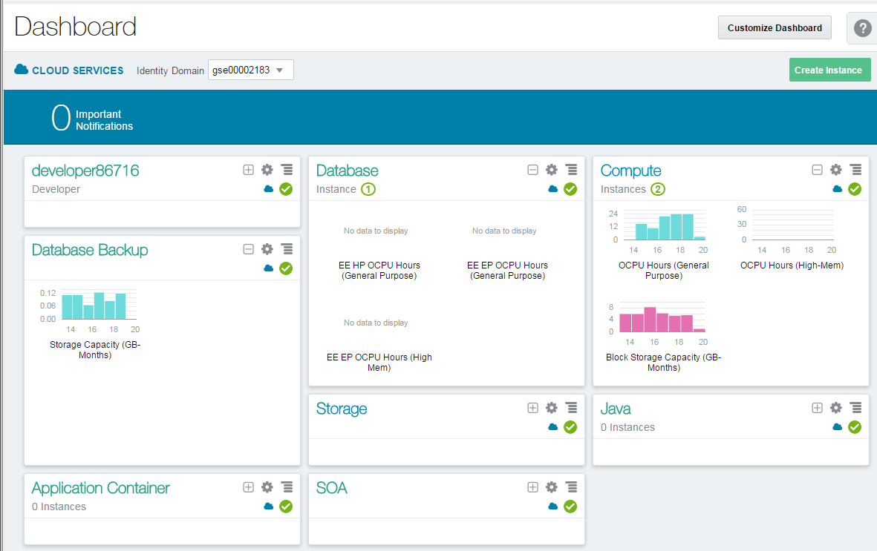

* If there’s a service that’s not visible, click on the Customize Dashboard dropdown and add each service as a favorite by clicking on theShow button next to the service.

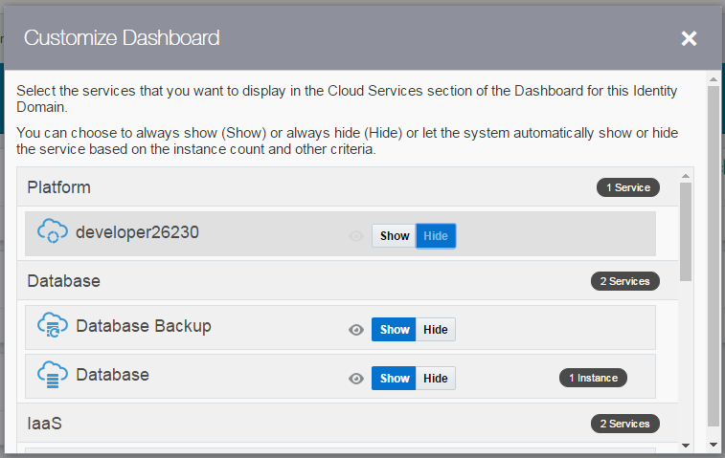

* From the main dashboard, click on the Compute service link to access the Compute Service Console. This is where we will get the IP address of our database service.

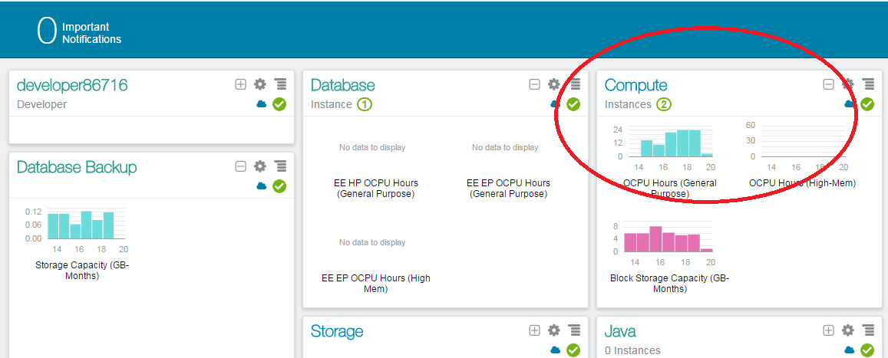

* From this page you can view general information about this Compute Cloud Service. Click on the Open Service Console button.

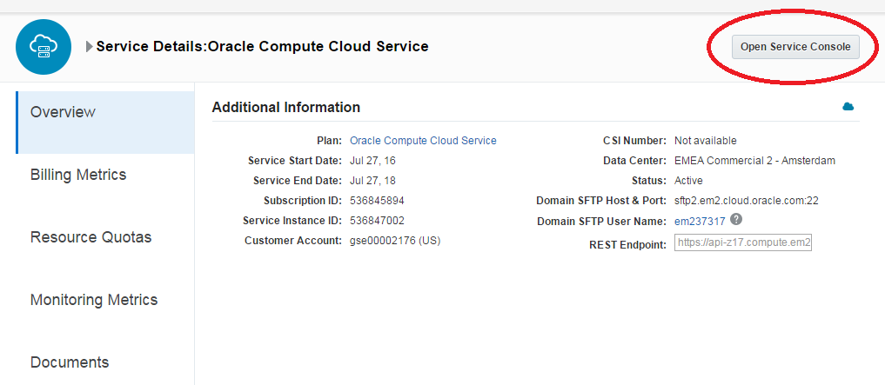

* The Compute Service Console will give you a summary of the resources your cloud service is using and a list all running VM’s.

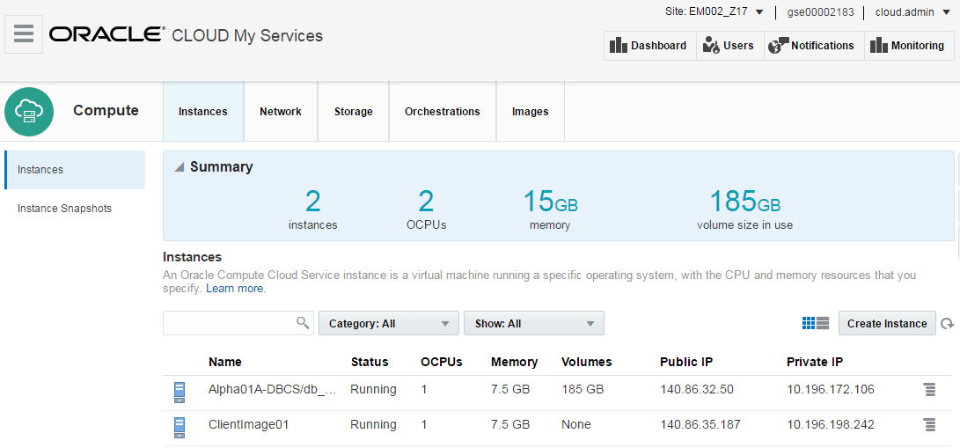

* Identity Domains have multiple sites. If you don’t see your VM images in the Compute Console, you may be in the wrong site.

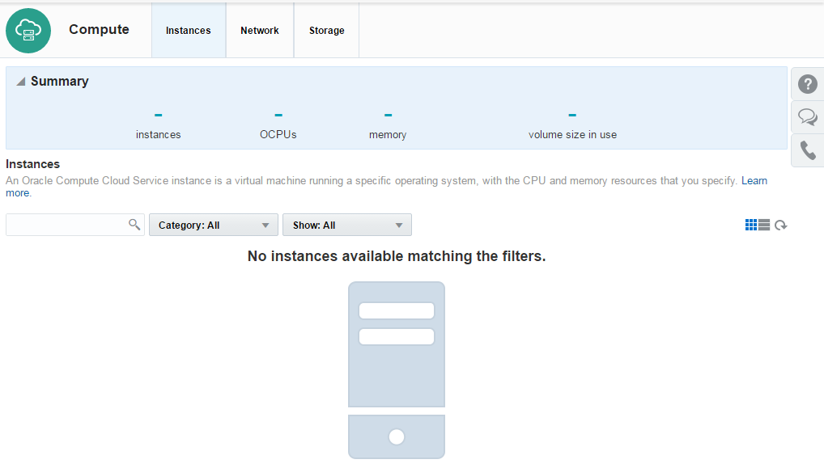

* Please ask your instructor which site the Client Image is running on. If necessary, click the Site dropdown at the top of the page to access the Site Selector and choose the correct site.

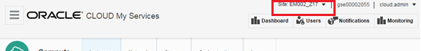

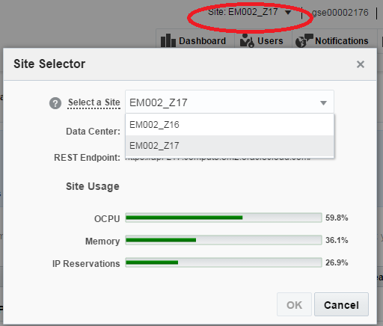

* Once the correct site has been selected, locate the instance named ClientImage01 and copy the Public IP.
* Note: Keep this IP Address somewhere accessible, like a notepad or text document. We will use this IP with VNC to connect to the cloud client desktop.

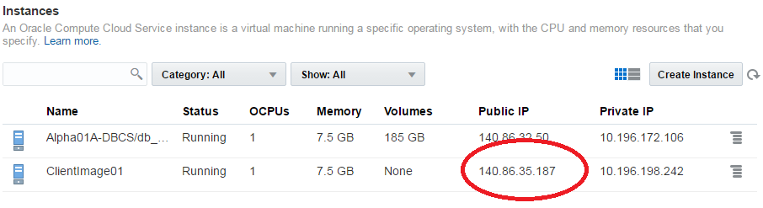

#### Connect to Client Image using VNC Viewer

* From your desktop run the VNC Viewer application and enter the Public IP address you just obtained, with a display port separated from the IP address by a colon <:443> and click Connect

***Note 1:*** *If connecting inside an Oracle office through the ‘clear-guest’ network, and the VNC session won’t connect or times out, try port :10.*

**Note 2:** If you do not already have a VNC Viewer installed on your computer you will need to download it. Or ask the instructor for the Real VNC Viewer executable.

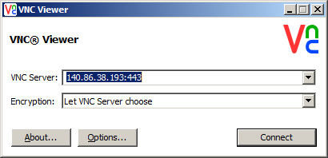

* Click Continue on the encryption message.

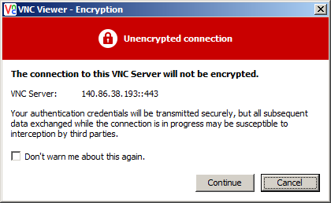

* Enter the password supplied by your instructor and click OK

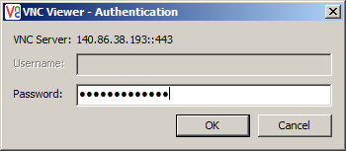

* Verify that you can see and interact with the Linux desktop. You are now connected to the Client Image that will be used for all labs.

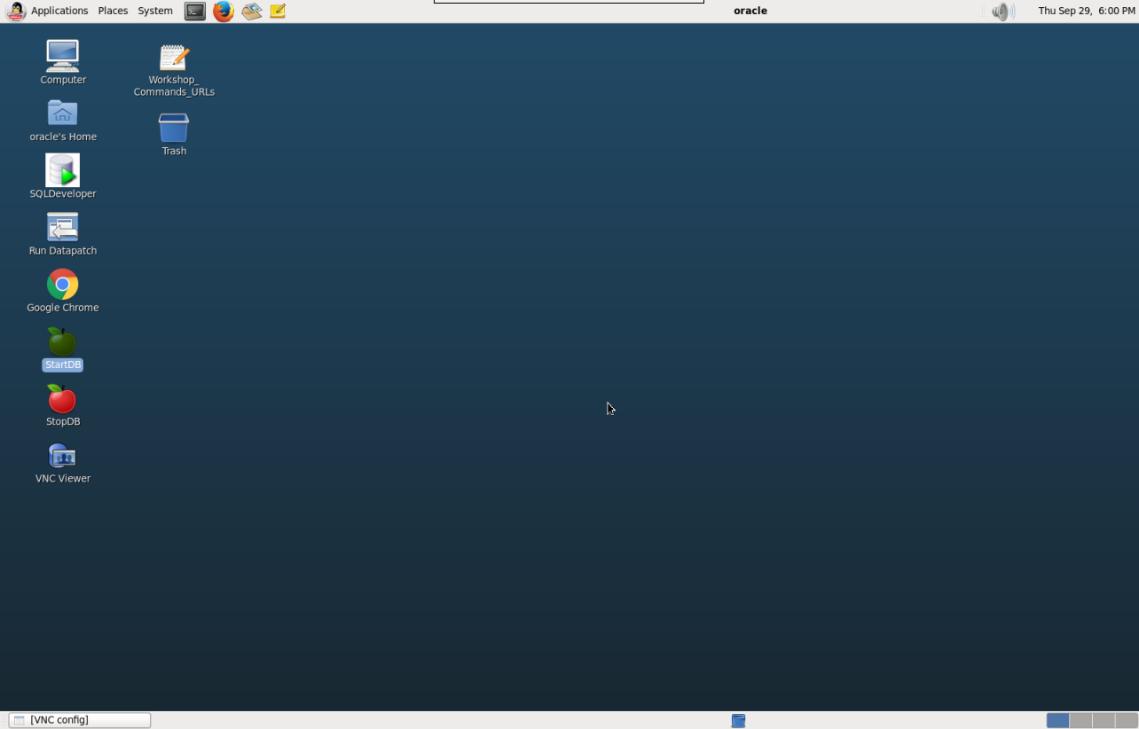

### Create Database Cloud Service Instance

#### Login to your Oracle Cloud account

* From within the VNC Session open the **Google** Chrome browser  and go to the following URL: [**https://cloud.oracle.com**](https://cloud.oracle.com)
* Click Sign In in the upper right hand corner of the browser
* Under the Cloud Account field click on the Select Data Center drop down, choose the data center location (for demos and trials, it’s usually EMEA) then click on the My Services > button.

**IMPORTANT** - Under My Services, the **Data Center location** is provided to you in the lab connection instructions.



* In the next screen enter the identity domain and click GO



* Enter the cloud User Name and Password and click Sign In



**NOTE**: The Identity Domain, User Name and Password values are provided in the lab connection instructions.

* You should see the Dashboard summarizing all of the available services.

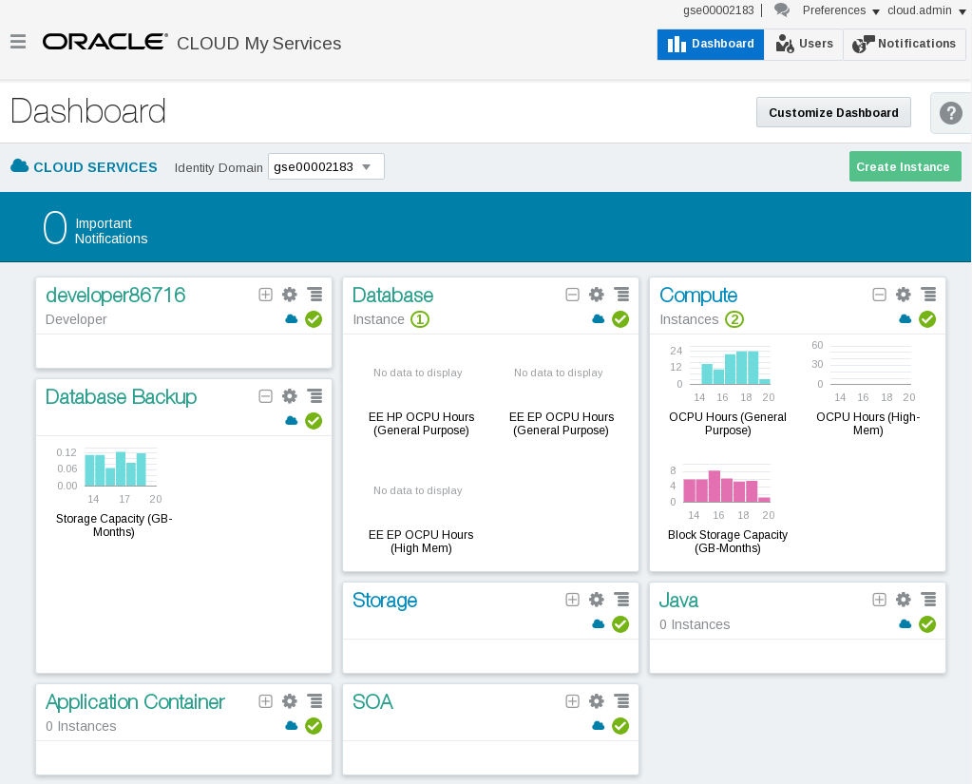

#### Create Database Cloud Service

* From the main dashboard, click on the Database service link

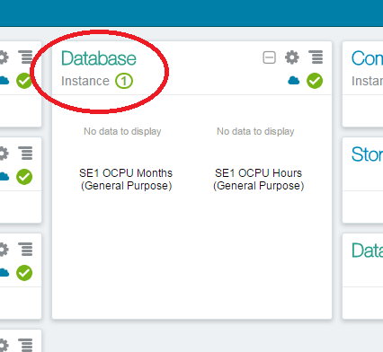

* From this page you can view general information about this Database Cloud Service. Click on the Open Service Console button.

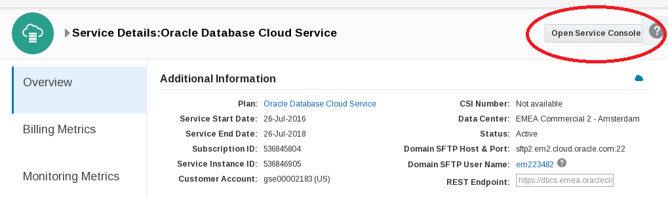

* From the console, click the Create Service button
* ***Note:*** *There should already be a service provisioned (Alpha01A-DBCS). It was created earlier in order to save lab time. This service will be utilized later in the lab, don’t interact with it at this point.*

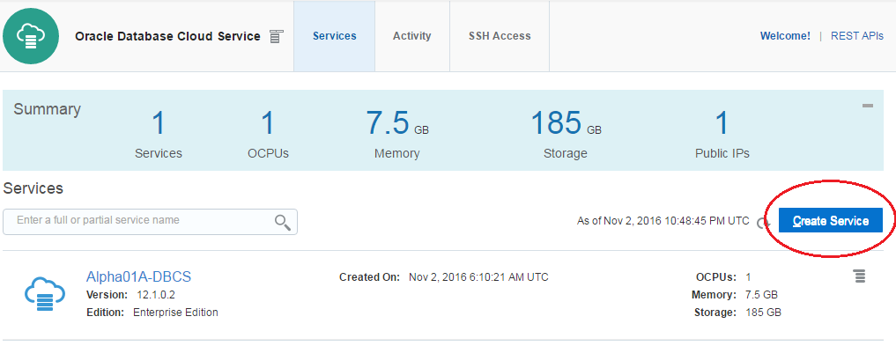

 Important Step! In the next steps, you will provide identity service configuration details and select the compute shape for your new Database instance.

**Note:** Service Name must be unique. When providing a name, please note you may have another service instance already created in your account.

* Use the information from the following table for the Service Configuration details:

|  |  |
| --- | --- |
| **Basic Service Information** | |
| **Service Name** | Alpha01B-DBCS |
| **Description** | Alpha Office Database Cloud Service |
| **Service Level** | Oracle Database Cloud Service |
| **Metering Frequency** | Hourly |
| **Software Release** | Oracle Database 12c Release 1 |
| **Software Edition** | Enterprise Edition |
| **Database Type** | Single Instance |

*Below are examples of the alternate selections for each*

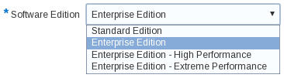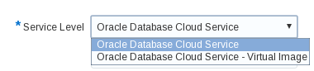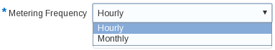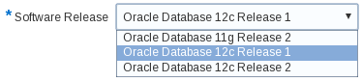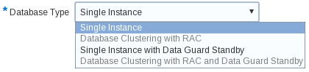

* Your screen should look like this …

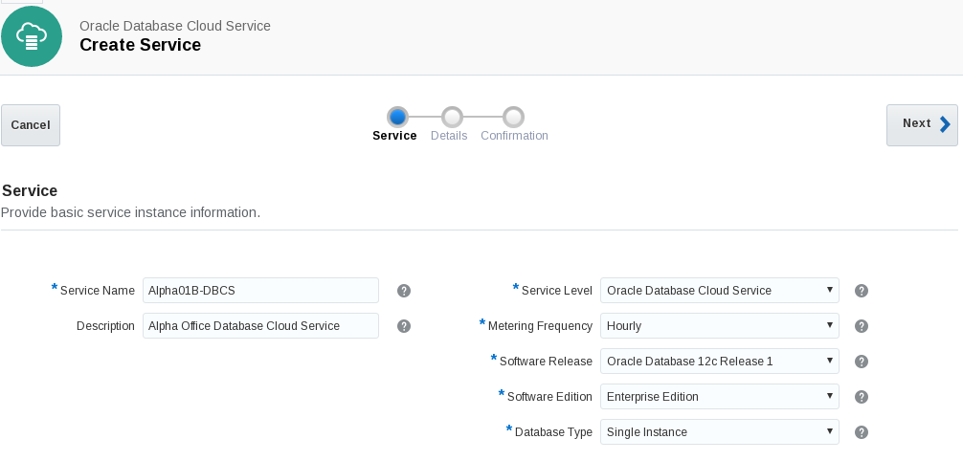

* Click **Next** to continue
* In the next screen we will fill out the **Service Details** for our Database Cloud instance. The screen will be broken down into sections to make the information easier to understand.
* Here is an example of the completed Service Details Screen. Continue to the next step for details on how to fill this form in correctly.

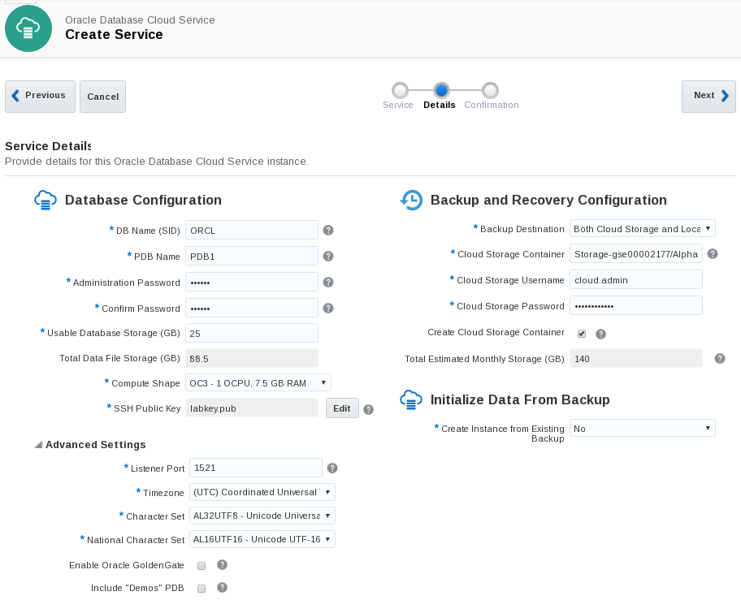

Section 1: Database Configuration:

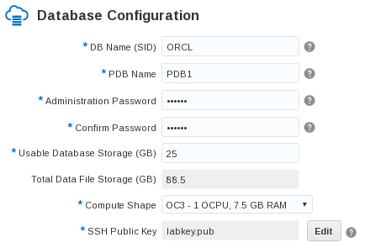

|  |  |
| --- | --- |
| **Section 1: Database Configuration** | |
| **DB Name (SID)** | ORCL |
| **PDB Name** | PDB1 |
| **Administration Password** | Alpha2014_ |
| **Usable Database Storage (GB)** | 25 |
| **Total Data File Storage (GB)** | 88.5 |
| **Compute Shape** | OC3 – 1 OCPU, 7.5 GB RAM |
| **SSH Public Key** | labkey.pub |

Note: The SSH Key has already been created for you. It’s named labkey.pub and can be found on the client image under /u01/OPCWorkshop/lab/

* On the SSH Public Key section, click Edit

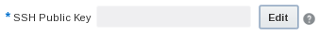

* Click on the Edit button to browse for the labkey.pub

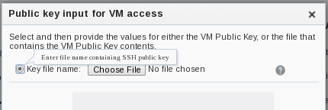

* Make sure the Key File name: radio button is checked and click Choose File
* Navigate to the following subdirectory on your system: /u01/OPCWorkshop/lab/
* Choose the file named labkey.pub

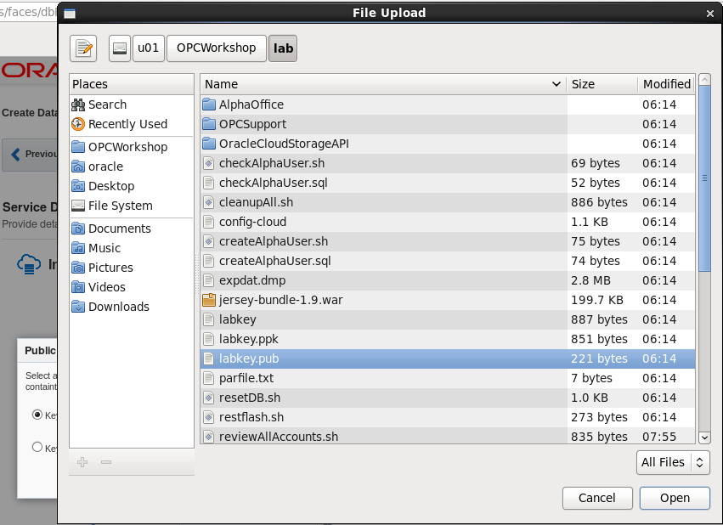

* Click Open and confirm that labkey.pub is shown on the screen

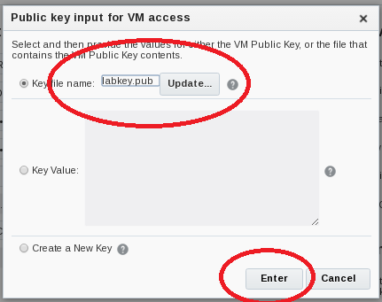

* Click **Enter** and continue filling out the Details form. Continue on to the **Backup and Recovery** and **Initialize Data From Backup Configuration** Sections

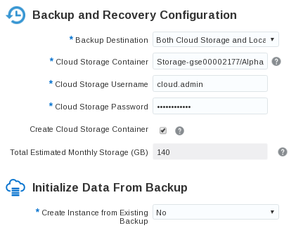

* Use the information from the following table to help fill out the **Backup and Recovery Configuration** and **Initialize Data From Backup** sections.

|  |  |
| --- | --- |
| **Backup and Recovery Configuration Information** | |
| **Backup Destination** | Both Cloud and Local Storage |
| **Cloud Storage Container** | Storage-<your domain name>/Alpha01B_DBCS_SC |
| **Cloud Storage Username** | cloud.admin |
| **Cloud Storage Password** | Use <cloud.admin> assigned password |
| **Create Cloud Storage Container** | Check box – Yes |
| **Total Estimated Monthly Storage (GB)** | Default 140 |
| **Create Instance from Existing Backup** | No |

**Note**: By checking the box labeled - **Create Cloud Storage Container**, if the container does not exist it will be created automatically. This will be the location for all backups

* Confirm the following information from the **Advanced Settings** section. This information is default and doesn’t need to be altered.

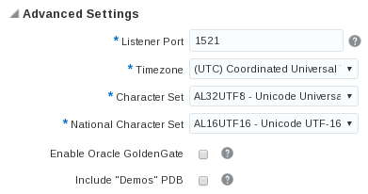

* After all fields have been filled out , click on Next

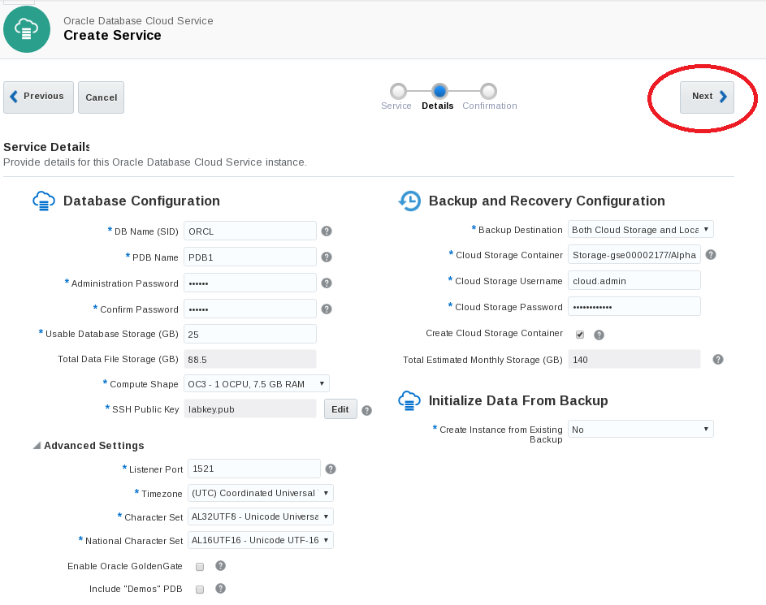

* Review the Confirmation screen and confirm that your entries are correct. When you’re satisfied that everything is in order click Create.

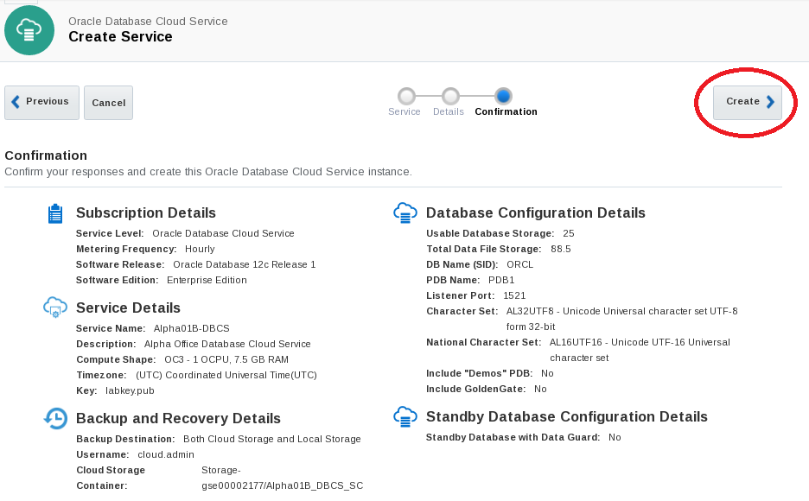

* You should be returned to the dashboard and your new Database Cloud Service instance Alpha01B-DBCS should be visible and labeled as ‘In Progress’

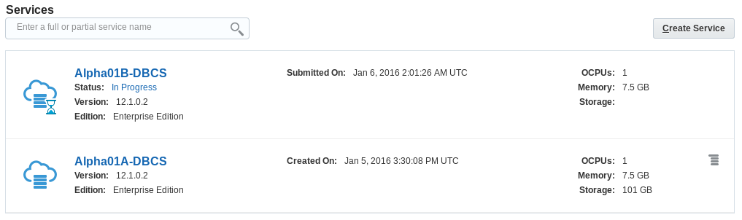

* The creation of the DBCS instance will take approximately 20 minutes. While your DBCS instance is being created, you can view the current status clicking on the In Progress link.

**NOTE**: To save time we will continue with the lab by utilizing Alpha01A-DBCS DBCS instance already created. Alpha01A-DBCS was created following the exact steps you just performed.

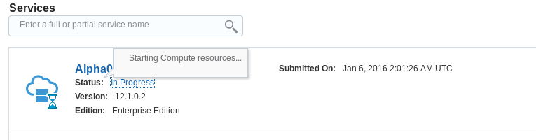

### Configuration and Image Exploration

#### Record the IP address of the Database Cloud Service

In the following steps you will record the IP addresses of the Virtual Machine on which the cloud service runs and configure SSH connectivity to Alpha01A-DBCS. Then you will access the different monitoring, configuration, and development consoles available on Oracle Database Cloud Service.

* Click on Alpha01A-DBCS link or cloud icon from the list of Database Instances to get further details on Alpha01A-DBCS



* Note the Public IP address of Alpha01A-DBCS. In the below example the address is 140.86.12.71, yours will be different.

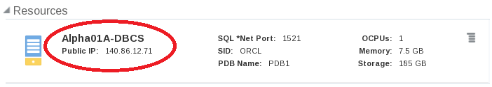

#### Create the SSH configuration file and start tunnels

For obvious reasons the default Oracle Public Cloud network configuration is very secure. Customers can open individual ports to the various servers in the cloud environment through the Compute Cloud Service Console or they can create SSH tunnels to the specific server/port combinations as needed.

In this section we will use **SSH Tunnels** to communicate securely between the client and the Cloud Database instance. We have built a *script that automatically creates these tunnels for you.* You will review the script later in the exercise so you can learn how to create them on your own.

We will show you how to use secure tunnels as well as how to open ports for the following exercises.

In step 1.6.2 you will run the script that creates and configures an SSH file that will be used to connect to your various servers. Once the SSH file is created, it is used as a script to create the SSH tunnels in the background with connections to selected ports used in this and other labs.

* Open a terminal Window using the Utilities menu or by clicking the terminal icon. 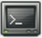
* Change into the lab directory cd lab
* Run the SSH script to open the ports. Type ./setssh.sh DBONLY in the terminal window

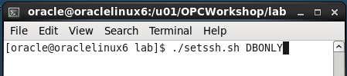

* If you make an error you’ll see:

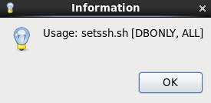

* Enter the Cloud Database IP address obtained in Step 1.6.1 and. Click OK.

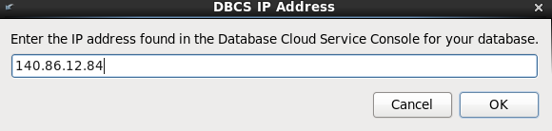

The script will try a test connection to your server. If successful, an SSH configuration file is created and an SSH session to the DB server will be started in the background.

If the script encounters any problems, or you entered the wrong address, you will be re-prompted to enter the IP address.

If the tunnels are created successfully you will see a Success Information Dialog.

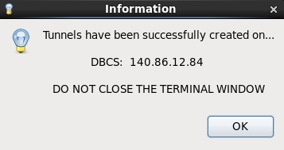

* Click OK on the dialog box to clear it.

**Note:** Do not close the terminal window that you used to run the SSH Configuration script. Closing the terminal window will shut down the background SSH tunnel processes. If you accidentally shut the terminal window, you can start over again at step 1.6.2 and run the script again. You might want to minimize this terminal window until you need to stop the tunnels.

* Examine the script to view and understand the commands used to start the tunnels.
* Type gedit mysshin the terminal window

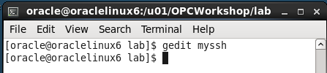

Notice under the **Host AlphaDBCS** section of the configuration file that the DBCS IP address has been inserted in 5 areas defining LocalForward ports (1526, 443, 4848, and 5500). Which correspond to host direct access, MySQL, APEX, DB Monitor, Glassfish, and Enterprise Manager. These ports can now be accessed locally using “localhost” in connection information or URLs.

**Tunneling Script Example:**

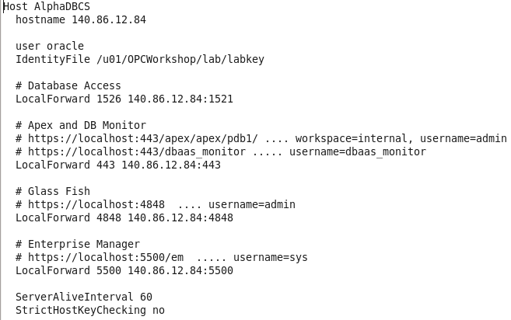

* Close the edit session.
* Type ps -ef | grep DBCS to see the background session created.

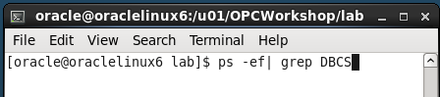

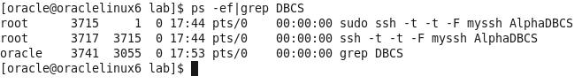

#### Explore DB image via SSH

In the previous step, you started SSH tunnels in the background for access to development tools and the browser. In this step we will demonstrate how to do an explicit SSH connection to your DB cloud server.

* Enter the below command in the same terminal window you ran the setssh.sh script, using the Public IP address of your DBCS cloud instance.
* $ ssh -o StrictHostKeyChecking=no -i ./labkey oracle@<**your-DB-Public-IP**>

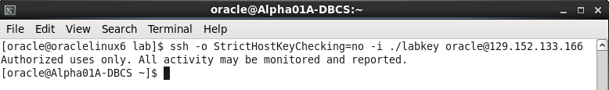

After successfully connecting to Alpha01A-DBCS you can browse the image.

* Issue a df command to see mounted disks and existing space.
* $ df -h

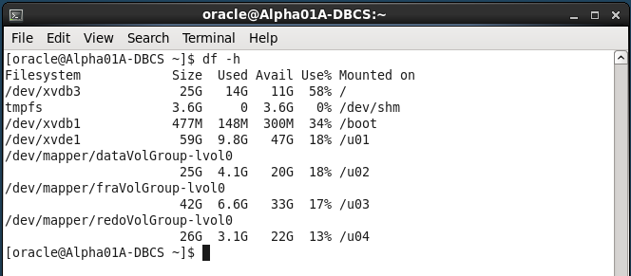

* View the Database environment variables.
* $ env | grep ORA

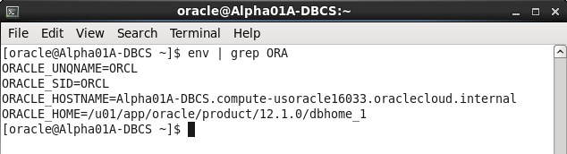

* Change directories to the Oracle Home and list the directories.
* $ cd $ORACLE_HOME
* $ ls

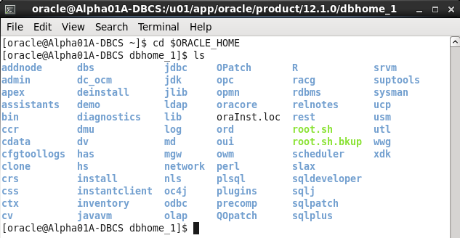

Type exit once to close the session.

$ exit

**NOTE:** By typing exit once, you are exiting the Cloud DBCS Service SSH session. If you are running commands in the same window you started the SSH tunnel scrip in and you type exit twice you will exit the terminal window and you will terminate the SSH tunnels. Do not exit the Terminal window, these SSH Tunnels will be used during the remainder of the lab. Feel free to minimize the SSH Tunnel terminal and start a new one to avoid accidentally closing the tunnels.

#### Access the Compute Cloud Service and open SSH ports for access.

**NOTE:** For any of the URLs mentioned in this section you can also use the predefined browser links. If blocked ports on the network cause an issue loading any of these consoles, the predefined browser links will help by routing the traffic through the SSH tunnel that should already be open:

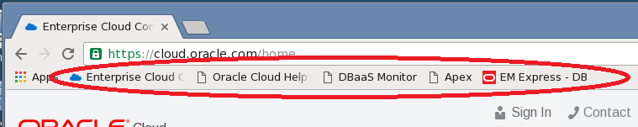

To gain access to the various consoles used by the Database Cloud Service you have two options. You can open up the port on which the monitor is listening, or you can create an SSH tunnel to the specific server/port combinations as needed. We have already created the SSH tunnels and those will be used to access the consoles we need for this lab.

In this step you will open the port 443 on the VM using a pre-created access rule and protocol definition.

* Return to your Cloud.oracle.com session on the Google browser. If you’ve logged out for any reason, log back into the cloud account using the details at the start of the lab.
* Click the header menu in the upper left next to Oracle Cloud My Services and choose the Compute Cloud console



* Click on Compute Cloud Service Console menu item

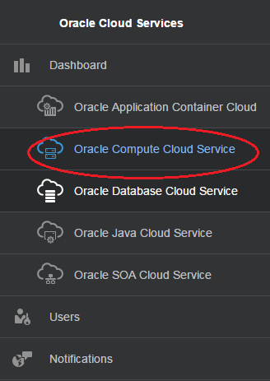

* Verify that you’re on the correct site and that the Alpha01A-DBCS and Alpha01B-DBCS instance are visible.

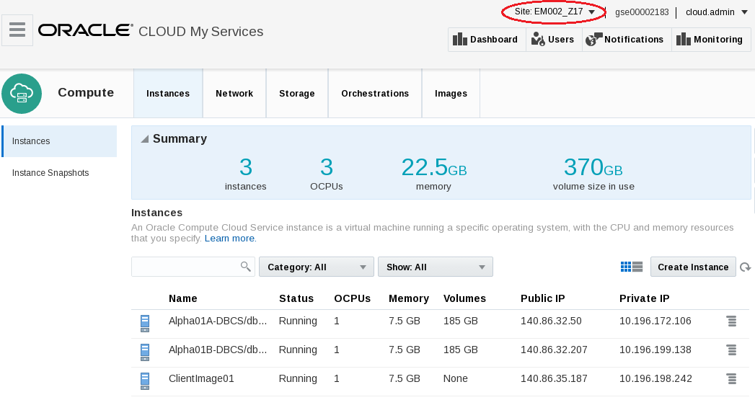

* From the top menu bar click on Network tab.

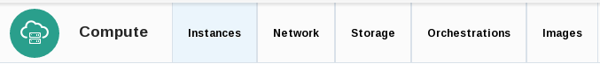

The Network section will allow you to manage security access, IP networking, and SSH information. There can be many entries so we’ll filter out what we’re looking for.

* With the Security > Security Rules section selected, type httpssl into the search box and hit enter or click the magnifying glass icon.

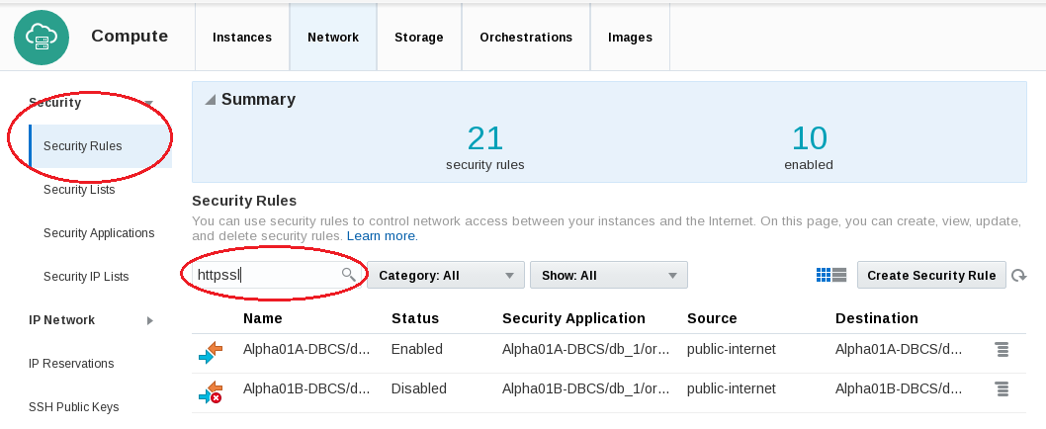

**Note:** If you can’t see the particular rule clearly, widen your browser screen or click on the table icon to change the view.

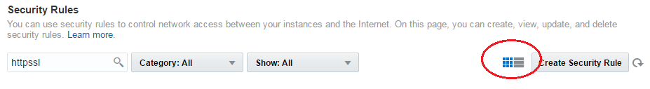

* For each instance there is an httpssl rule called ‘ora_p2_httpssl’.
* To change the rule for the Alpha01A-DBCS instance click on the hamburger menu  or on the colored arrows and select Update

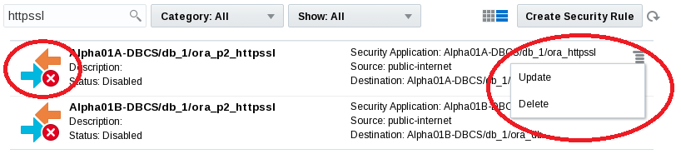

* Change Status to Enabled and click Update

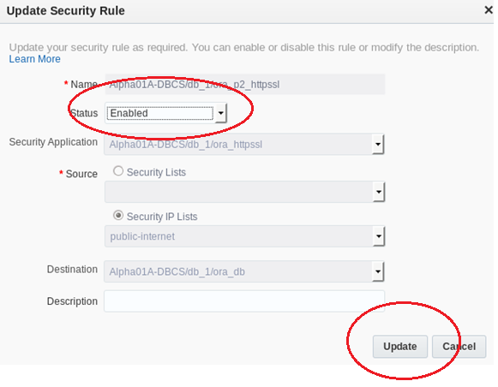

* Notice the status change for the ora_p2_httpssl Access rule to Enabled. The port is now open and can be accessed without the tunnels if necessary.

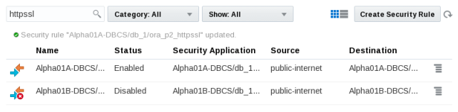

* Navigate back to the Database Cloud Service Console by clicking the header icon and selecting Database Cloud Service.



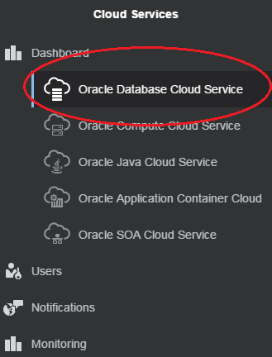

* For the Alpha01A-DBCS instance click the hamburger menu  and select Open DBaaS Monitor Console.

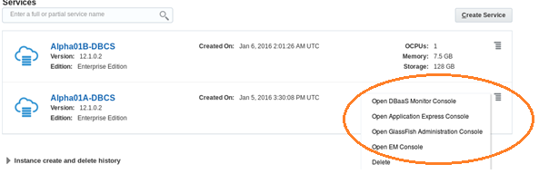

* You will likely get a security warning, click ADVANCED followed by Proceed to <your IP Address> (unsafe)

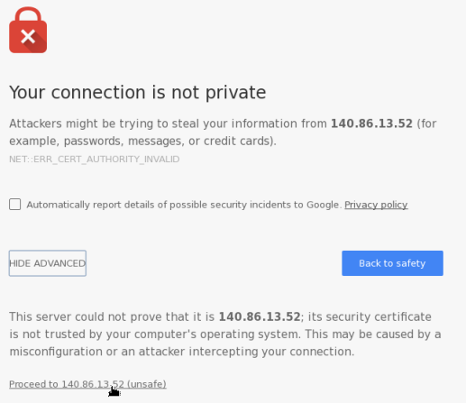

* Login to the DBaaS monitor

|  |  |
| --- | --- |
| **User Name:** | dbaas_monitor |
| **Password:** | Alpha2014_ |

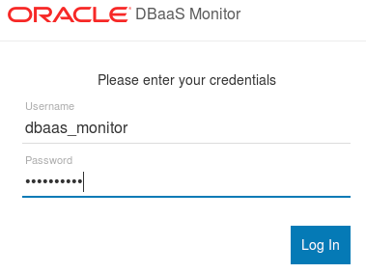

* Once connected to the Database Monitor Console, feel free to explore the various screens. Click on the header items to familiarize yourself with DBaaS monitor.
* Logout when finished

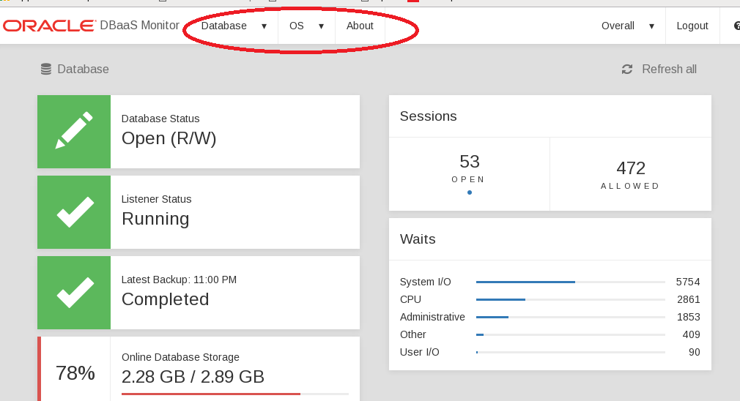

#### Access Enterprise Manager DB Express

* On the browser, open a new tab and enter the following URL to access the EM Express page. The first time the URL is used, it can take a minute for the console to load.

Note: The setssh.sh script that you ran earlier in this lab created the ssh tunnel which routes all traffic over localhost:5500 to the database cloud service.

* https://localhost:5500/em

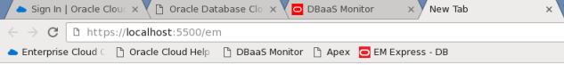

* If you get a security warning, click ADVANCED followed by Proceed to localhost (unsafe)

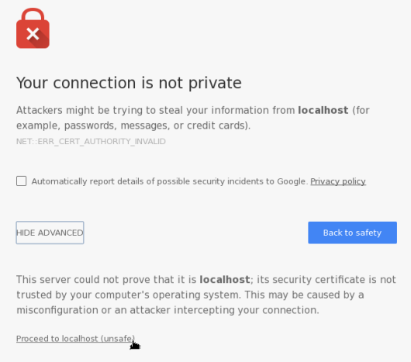

* On the EM login page enter the following and click on Login:

|  |  |
| --- | --- |
| **User Name:** | sys |
| **Password:** | Alpha2014_ |
| **Checkbox:** | “as sysdba” |

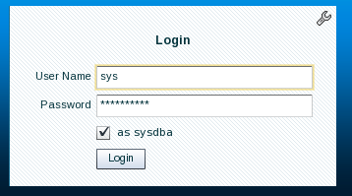

* Click on different items on the Enterprise Manager console to get familiar with its capabilities.
* Logout when finished.

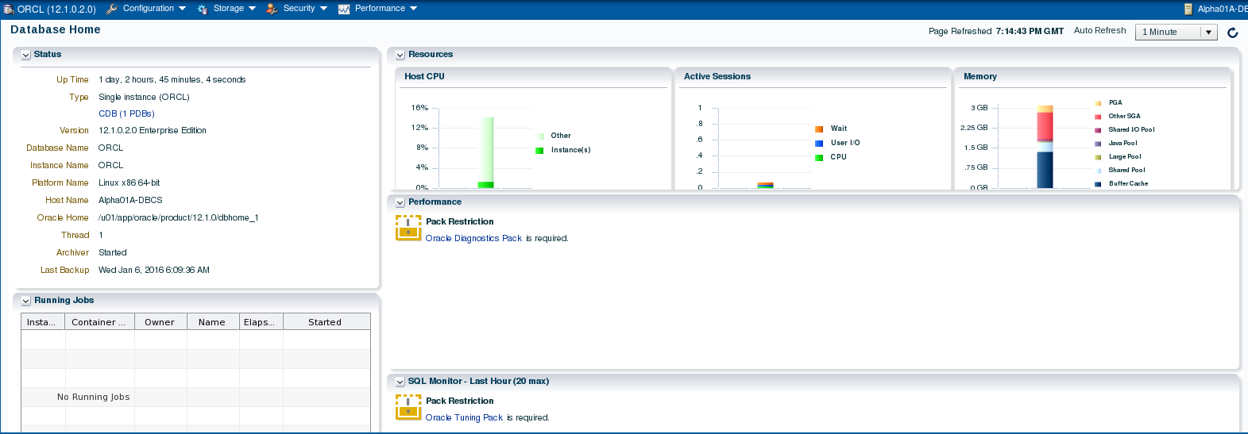

#### Access Apex Monitor

* Enter the following URL into a browser window to access the Apex console (click to add a security exception if necessary).

Note: All traffic to the default https port (443) on local host is also routed through the SSH tunnel to the database cloud service.

* https://localhost/apex/pdb1/

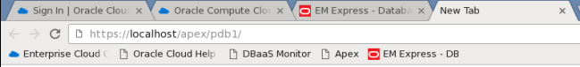

* If you get a security warning, click ADVANCED followed by Proceed to localhost (unsafe)



* Once the Apex login window is displayed, enter the following and click on Sign In:

|  |  |
| --- | --- |
| **Workspace:** | internal |
| **Username:** | ADMIN |
| **Password:** | Alpha2014_ |

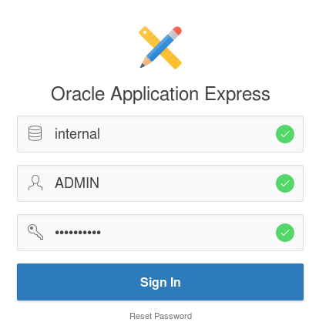

* You are now connected to Apex. Feel free to explore the various menu options. The last lab in this workshop will walk you through the creation of a simple application.
* Log out of APEX when you are finished.

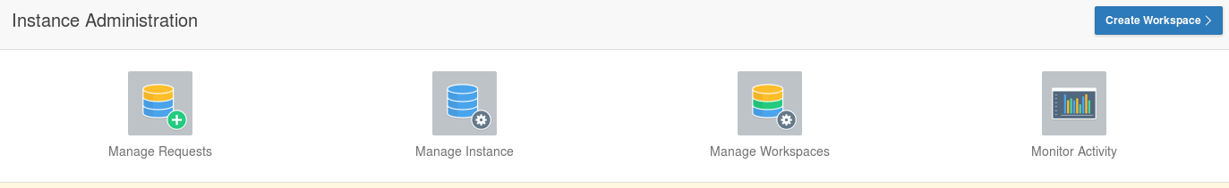

* This concludes the first lab, Overview of DBCS. Proceed to the next lab when ready.

# Cloud Migration

### Introduction

In this lab you will explore some common methods for moving data from on premise to the cloud. There are multiple options for solving this data movement challenge. In this lab we will use SQL*Developer and command line tools to clone and move a pluggable database from an on premise database (in the provided Virtual Machine) to a cloud database. We will also use standard Oracle Data Pump tools to export a schema from the on premise database, and then import that data to a cloud database in a new schema. The final exercise will use the SQL Developer cart feature to quickly move data from the local database to the cloud using only the privileges of a normal schema owner.

### Objectives

* Clone, unplug, transfer, and plug the AlphaPDB pluggable database using SQL Developer.
* Export and import a schema using SQL Developer to execute Oracle Data Pump jobs.
* Export and import a small collection of tables using SQL Developer.

### System Requirements

* VNC Viewer for connection to client system
* Successful completion of Section 1: Database Cloud Service Overview lab.
* The SSH tunnels must be active in a terminal window in the client system

### Cloud Migration Using Pluggable Databases

In this section of the lab we will prepare the on premise environment and create connections. Then we’ll clone the database. We’ll create SSH connections to the cloud instance and finally we’ll copy the clone to the public cloud using Oracle SQL Developer. Once the database has been cloned we will patch the instance to bring it up to date with the Cloud Container database. We will verify successful patching and login in to the newly migrated Database instance.

#### Configure the Environment

* From the VNC Session desktop, locate and double-click on the StartDB icon. It will take a minute for the Database to fully start. Once started, the Terminal Log Window will automatically close.

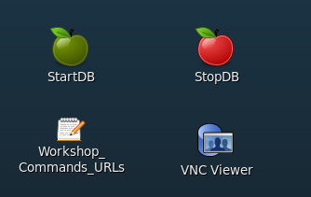

* From the VNC Session desktop, locate and double-click on the SQL Developer icon. We will use SQL Developer to connect to the on premise database.

**NOTE:** The first time SQL Developer is brought up, it may a few minutes to start up.

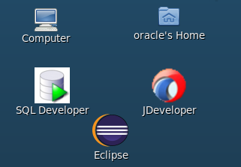

* Double-click the On-premise folder or click on the plus sign next the folder to expand the list of database connections. Please note the pre-configured connections to the on-premise database, Alpha – PDB, sys- AlphaPDB and sys-CDB.

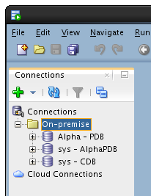

**Alpha - PDB**

This is a normal database connection to the *alpha* schema inside the Alpha pluggable database.

**sys - AlphaPDB**

Privileged *sys* account in the Alpha pluggable database.

**sys - CDB**

Privileged *sys* account for the on-premise container database.

* Select the View -> DBA menu option from the top dropdown menu to open up the DBA navigator panel.

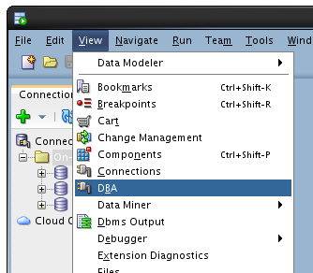

* On the DBA panel, click the green plus icon to create a new connection.

**Note**: you can also right-click on the green plus sign under Connections and select Add Connection.

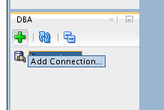

* Select the sys - CDB connection and click OK.

**Note:** “sys – CDB” is the on premise database located on the virtual client Image.

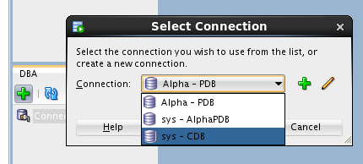

* Expand the sys - CDB connection by double clicking or by clicking on the plus sign, then expand the Container Database tree item. Click on the ALPHAPDB pluggable database item and view the details for the pluggable database.

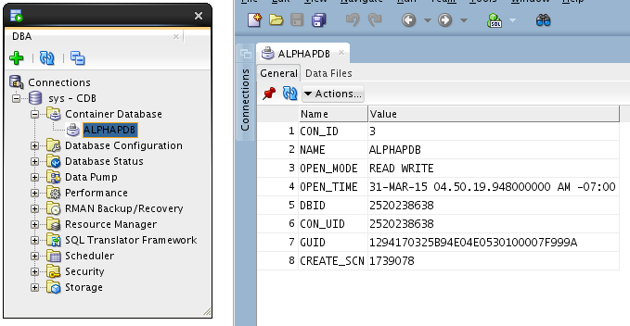

#### Clone the ALPHAPDB

* In the DBA Navigator panel, right click on the ALPHAPDB pluggable database and select the Clone Pluggable Database… menu option.

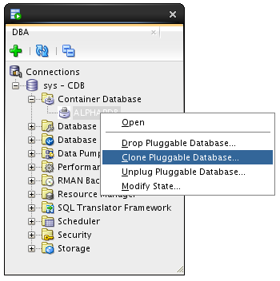

* Enter the following: Database Name: **ALPHACLONE**

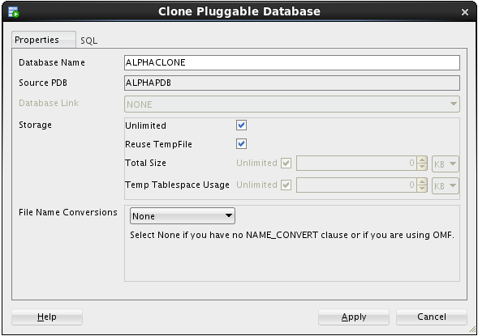

* Select Custom Names from the File Name Conversions section and review the Source File names. Note the name "**/AlphaPDB/**" for the directory of the source file names. For a successful cloning operation, we must create new target files that are different than the source files.

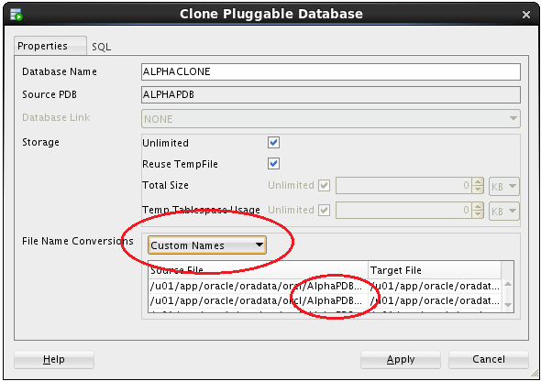

**Note**: At this point we could manually change all the target files to point to a different directory, but following are directions for an easier way to do this.

* Select Custom Expressions from the File Name Conversions drop down.
* Click the green plus icon
* Enter the source directory portion we want to change, followed by the target for the new files. Use the information from the table below being sure to use the indicated upper and lower case letters:

|  |  |
| --- | --- |
| **Source File Pattern** | AlphaPDB |
| **Target File Pattern** | AlphaClone |

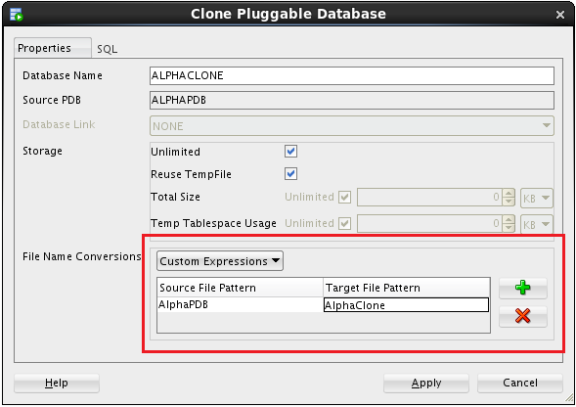

* Review the SQL statement by clicking on the SQL tab - note the **FILE_NAME_CONVERT** clause mapping the existing files to new files in a new directory.
* Click the Apply button.

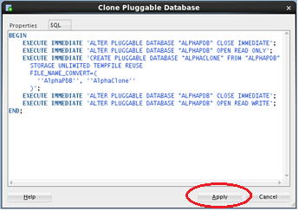

* SQL Developer shows the action in-progress message for roughly 1-2 minutes followed by a success message.
* Click OK on the success message.

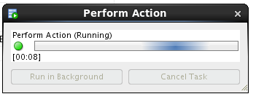 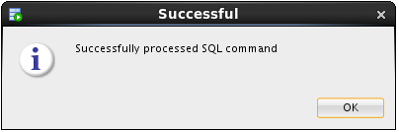

* Click on the ALPHACLONE database in the DBA navigator to see the status of the database.

**Note**: the cloned database shows an **OPEN_MODE** of **MOUNTED** indicating the database is plugged-in but is not open for access.

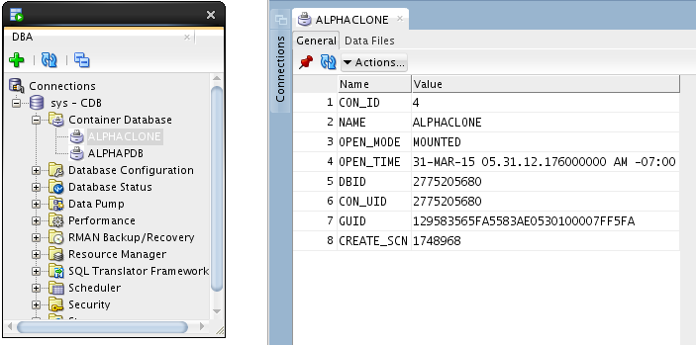

* Click on the Data Files tab for the ALPHACLONE to review the data files created during the cloning operation.

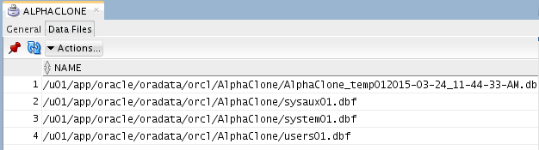

#### Create SSH Host

In this section you will create SSH and SYS database cloud connections.

In the following steps you will record the IP addresses of the Virtual Machine on which the cloud service runs and configure SSH connectivity to Alpha01A-DBCS. Then you will access the different monitoring, configuration, and development consoles available on Oracle Database Cloud Service.

* If you haven’t already noted down from the last lab, determine the Public IP address of Alpha01A-DBCS as we’ll be using that IP to set up our SSH connection for the data migration exercises.
* Open a browser and login to cloud.oracle.com using the credentials provided by your instructor.
* Click on the hamburger menu at the top right of the Database service section in the Dashboard and choose “**Open Service Console**”

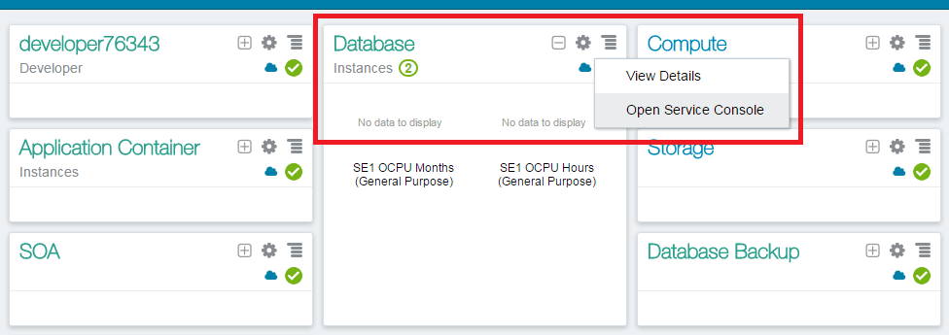

* Click on Alpha01A-DBCS from the list of Database Instances

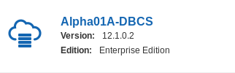

* Note the Public IP address of Alpha01A-DBCS. The IP address for your lab will be different than the one in the below screenshot.

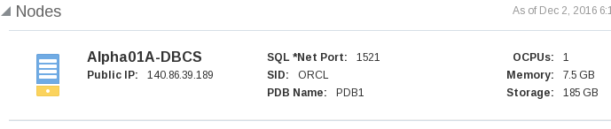

* Now we can setup an SSH host connection to the Database Cloud Service instance.
* Return to SQL Developer. From the top menu select View -> SSH to display SSH hosts panel on the left.

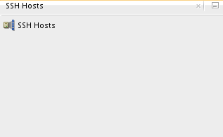

* Right click on SSH Hosts and select New SSH Host.

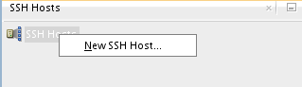

Enter the following information to configure the SSH connection to the DBCS instance

|  |  |
| --- | --- |
| **Name** | Alpha01A-DBCS |
| **Host** | Public IP of Alpha01A-DBCS |
| **Username** | oracle |

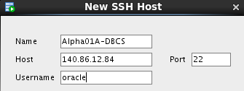

* Select Use key file and click Browse... Select file /u01/OPCWorkshop/lab/labkey and click Open.

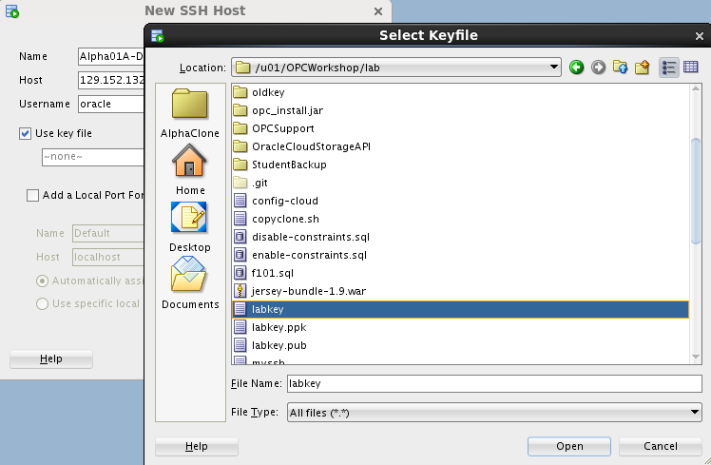

* Click Add a Local Port Forward and enter the following values:

|  |  |
| --- | --- |
| **Name** | Database |
| **Host** | Public IP of Alpha01A-DBCS |
| **Use specific local port** | 1530 |

**NOTE**: We are using port 1530 since 1521 is already in use for our local database.

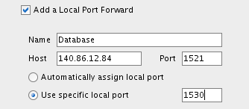

* Verify the configuration and click OK
* Click the green plus sign  in the Connections window to create a new SQL Developer connection to the Public Cloud Database SYS schema
* Enter the following connection details:

|  |  |
| --- | --- |
| **Connection Name:** | sys - OPCDBCS |
| **Username:** | sys |
| **Password:** | Alpha2014_ |
| **Check:** | “Save Password” |
| **Connection Type:** | SSH |
| **Role:** | SYSDBA |
| **Service Name:** | ORCL.<Your Domain ID>.oraclecloud.internal |

***Note:*** *You can optionally select a color for the connection to differentiate it from other connections.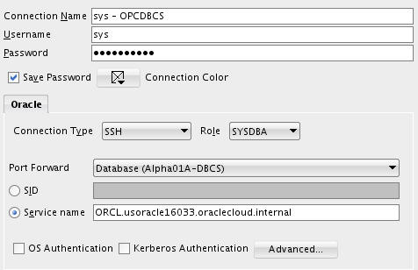*

* Click Test to confirm the information was entered correctly. Verify that you receive a ‘Success’ status.

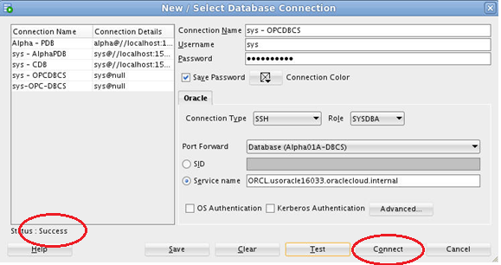

* Click Connect to save the connection information which opens a new SQL Worksheet.

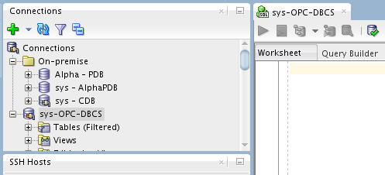

#### Copy the Clone Pluggable Database to the Cloud

In this step we will copy the cloned pluggable database to the cloud using SQL Developer.

* Click on View🡪Task Progress to open up the Task Progress window.
* In the DBA window expand ‘**sys – CDB**’ and expand ‘**Container Database**’, then right-click on ALPHACLONE and select “Clone PDB to Oracle Cloud”

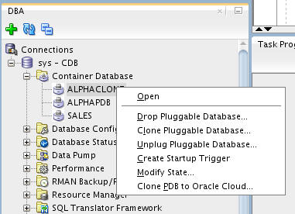

* Nothing needs to be changed in this window, verify that the default properties include your Public Cloud Connection. Click Apply.
* Source PDB: ALPHACLONE
* Destination Connection: sys - OPCDBCS
* Action after clone: RePlug

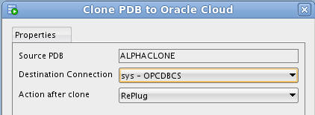

* You will note in the Task Progress window the progress of moving the datafiles over to the cloud database. This task will take about a minute to complete.

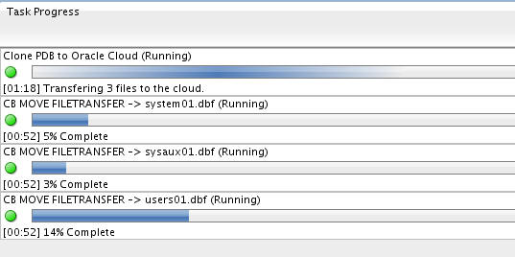

* Upon completion of the transfer you will be alerted to at least two Plugin Violations. This is because the patch level of the local ALPHACLONE pluggable database is different than the Container database in the cloud. We will remedy this in the next few steps.
* Click **OK** for **each** popup.

**Note:** The datafiles will be transferred despite what the pop up implies.

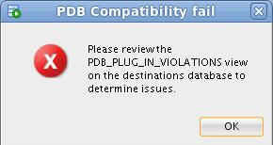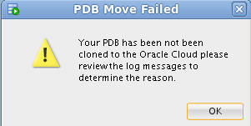

#### Use EM Express to plug the transferred database

* Open Chrome by clicking the icon on the menu bar or the Desktop.



* Enter the following URL into the Address bar or click the "EM Express - DB" link in the header bar – **https://localhost:5500/em**

**Note:** When using localhost:5500 in the URL below, your browser request is routed through the SSH proxy that we loaded in a terminal window in the first lab. If for some reason that window was closed, or is not working, you should refer to the first lab in step 1.6.2

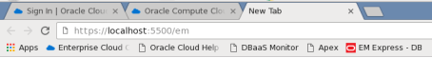

* Enter the following login credentials, check the "as sysdba" box and click the Login button:

|  |  |
| --- | --- |
| **User Name:** | sys |
| **Password:** | Alpha2014_ |
| **Check:** | as sysdba |

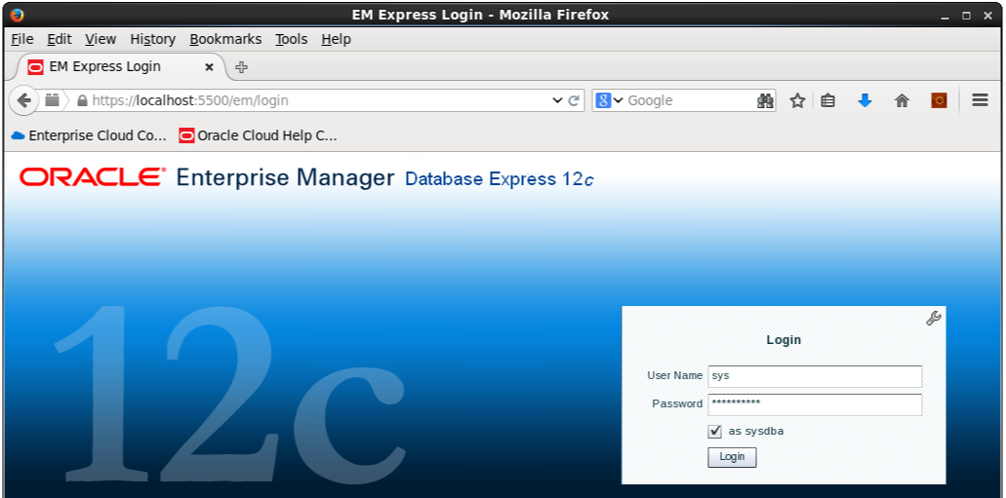

* We will now plug the Alpha Clone database into the Cloud database. From the Database Home page, click the CDB(1 PDBs) link.

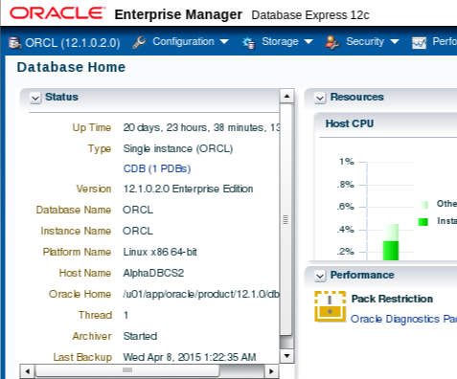

* Open the Actions list and select the Plug command

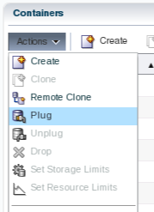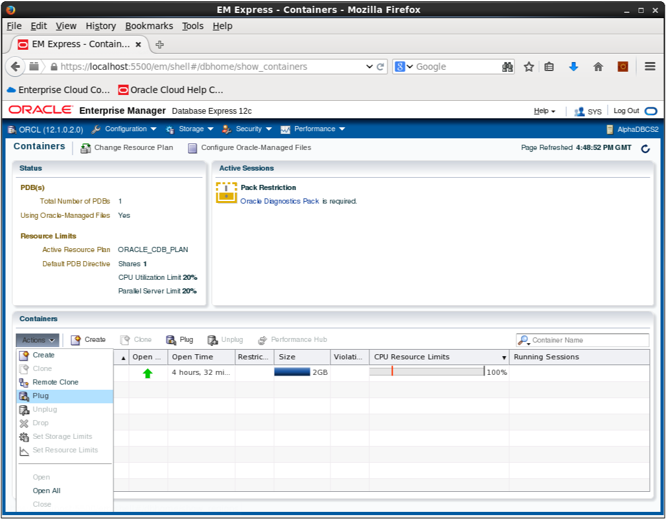

* Enter the following filename and directory location in the Metadata File field in the Plug PDB dialog box.

Metadata File: **/u02/app/oracle/oradata/ORCL/ALPHACLONE/ALPHACLONE.XML**

* **Uncheck** the **Reuse source datafile location from Metadata File** check box
* Enter the Source Datafile Location:

Source Datafile Location: **/u02/app/oracle/oradata/ORCL/ALPHACLONE**

* Click OK

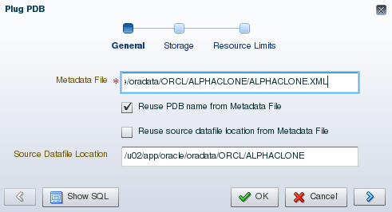

* The Processing message displays for the 2 minutes (approximately) required to plug the database into the container. Click the OK button when the Confirmation message displays.

|  |  |  |
| --- | --- | --- |
|  |  |  |

* Notice the database is now in the list of Containers**.**

**Note: There will be Violations because of the patch level mismatch between the original source Pluggable database and the Cloud Container database**.

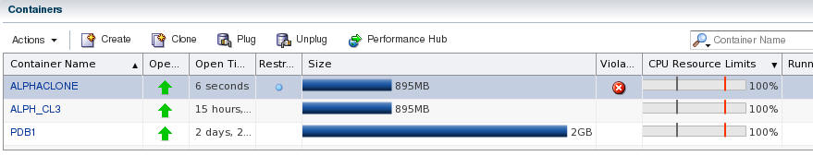

* You now need to SSH into the Cloud database server in order to patch the database. Example is shown below. Substitute your Cloud database server IP address (Alpha01A-DBCS)
* Open a Terminal and type the following SSH command to connect to the cloud database server.
* ssh -o ServerAliveInterval=60 -i /u01/OPCWorkshop/lab/labkey oracle@<Alpha01A-DBCS-IP-address>

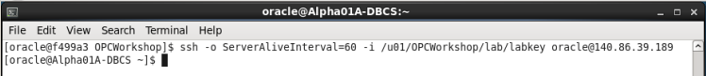

* We’ll need to run the datapatch script to apply any missing patches. It should run with no errors.

**Note: If it complains the first time about not being able to determine the current opatch status then wait a minute until it’s had time to pick up the newly cloned pluggable database and retry.**

* $ORACLE_HOME/OPatch/datapatch -verbose

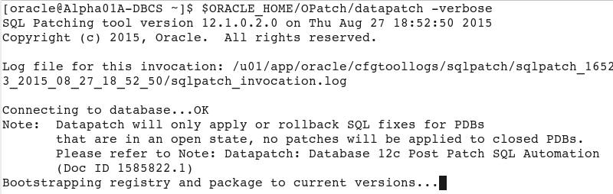

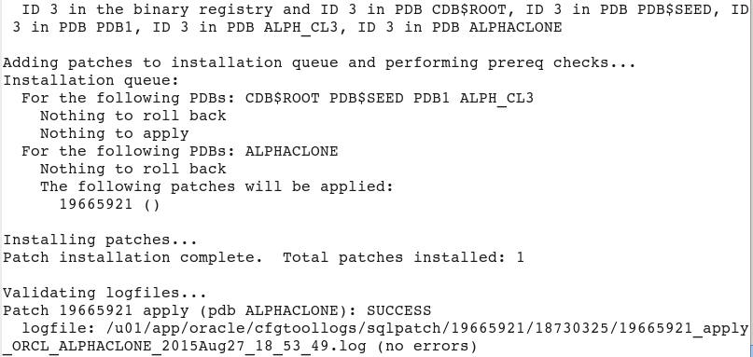

In the next few steps we’ll upgrade the PDB.

**Note:** If you receive an error message like, “The pluggable databases that need to be patched must be in upgrade mode” complete the following upgrade PDB Step. If not, proceed directly to the next step (Close and Reopen ALPHACLONE PDB).

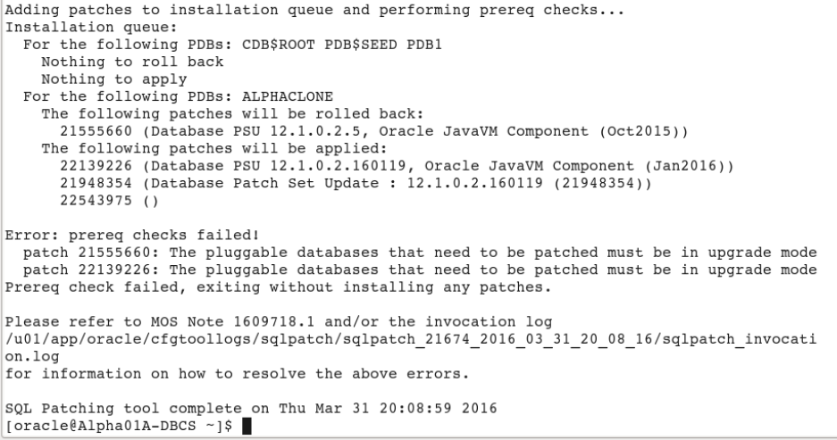

* Put the database in upgrade mode to correct the patch errors.
* Connect to container database using SQL Plus and place the database in upgrade mode. Once completed run datapatch again and you should have no errors. Run the following commands to complete this step.
* sqlplus / as sysdba
* alter pluggable database ALPHACLONE close;
* alter pluggable database ALPHACLONE open upgrade;
* exit
* $ORACLE_HOME/OPatch/datapatch -verbose

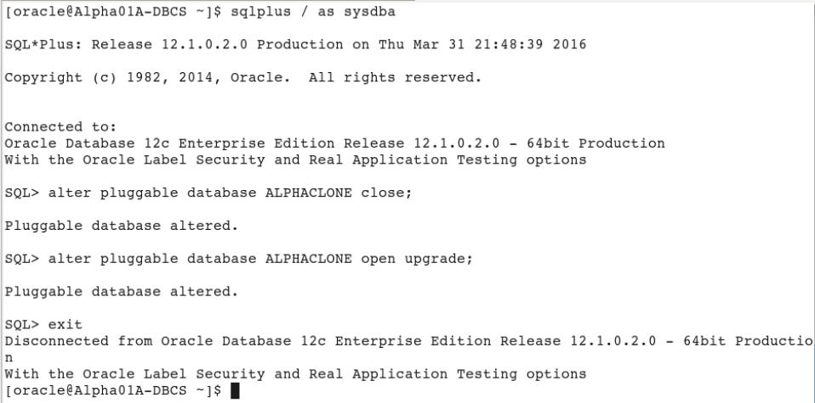

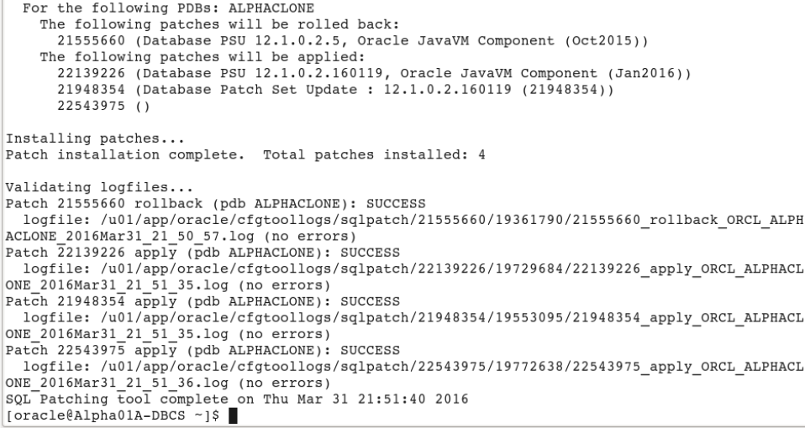

* **Close and Reopen ALPHACLONE PDB**
* The final step is to close and reopen the ALPHACLONE pluggable database. Go back to EM Express, with the ALPHACLONE row highlighted. (DO NOT CLICK THE ALPHACLONE LINK).
* Select **Actions 🡪 Close**.

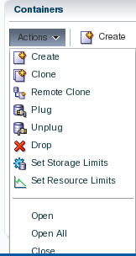

* Accept the defaults and Click **OK**.

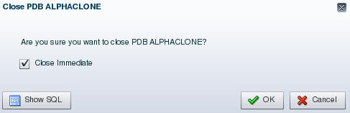

* Close the Confirmation pop up by clicking **OK**.
* Reopen the pluggable database via **Actions 🡪 Open**.
* Accept the default to open it Read / Write. Click **OK**.

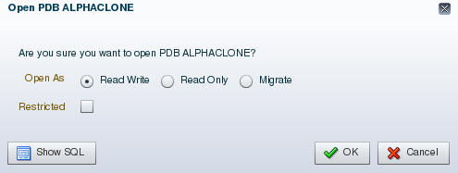

* Close the Confirmation pop up by clicking **OK**.
* Refresh the browser page using the refresh icon in the top right corner.

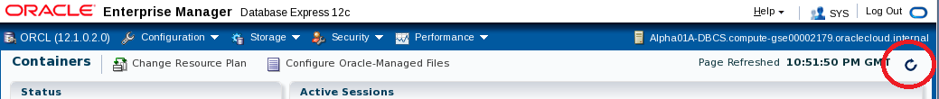

* Note that the violations are now gone.

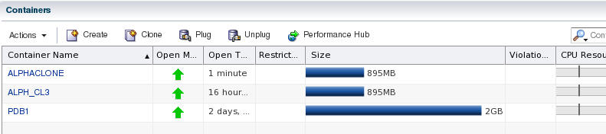

* Click the ALPHACLONE container name link to review the database information.

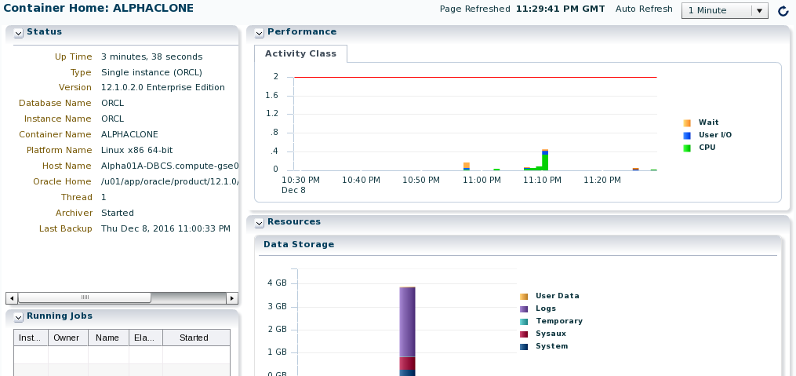

#### Create an SQL Developer connection to the Public Cloud database ALPHACLONE schema

* In the SQL Developer application, click the green plus sign  in the Connections window to create a new connection; enter the following connection details:

|  |  |
| --- | --- |
| **Connection Name:** | Alpha Clone – DBCS |
| **Username:** | alpha |
| **Password:** | oracle |
| **Check:** | “Save Password” |
| **Connection Type:** | SSH |
| **Service Name:** | Alphaclone.<Your ID Domain>.oraclecloud.internal |

***Note:*** *You can optionally select a color for the connection to differentiate it from other connections.*

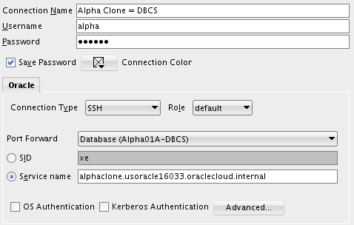

* Click Test to confirm the information was entered correctly.

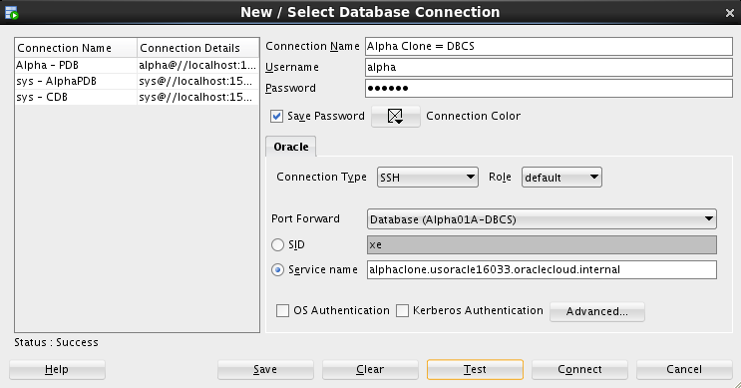

* Click Connect to save the connection information and open a new SQL Worksheet.

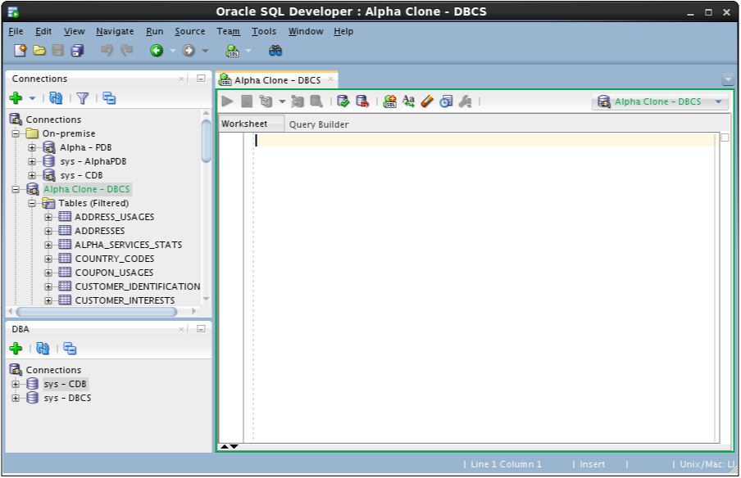

* You have successfully migrated a pluggable database from on premise to the cloud. In the next section we’ll migrate data using Data Pump.

### Cloud Migration Using Data Pump

#### Export the Alpha Schema

The first step will be to create a local Data Pump Directory.

* In the Connections Tab inside the "On-Premise" folder navigate to the Alpha - PDB 🡪 Directories item, right-mouse click and select Create Directory…

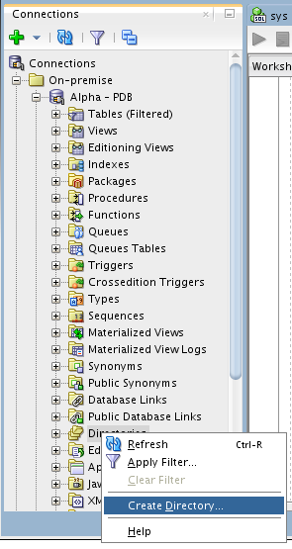

**Note**: The default Data Pump directory object, DATA_PUMP_DIR, does not work with PDBs. Data Pump requires an explicit directory object within the PDB for exporting or importing schemas or tables.

* Enter the following values and click Apply. Remember to use the SQL tab to review the actual DDL statement. Click OK to dismiss the confirmation.

|  |  |
| --- | --- |
| **Directory Name:** | alpha_backup_dir (not case sensitive) |
| **Database Server Directory:** | /u01/OPCWorkshop |

**NOTE:** You may receive an error message stating that “An error was encountered performing the requested operation:” and that the directory cannot be created. To eliminate this error right-click on Alpha - PDB and choose Disconnect. Then Reconnect. The error occurs because you were connected earlier while performing the UNMOUNT / REMOUNT and during the previous “cloning” of the PDB container the connection information was lost. Reconnecting will normally solve this issue.

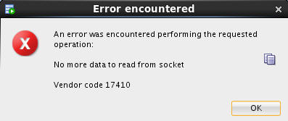

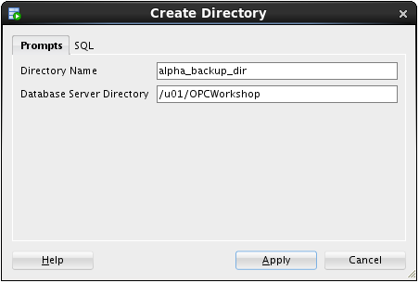

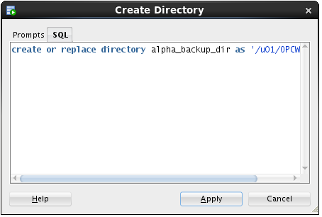

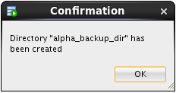

**Stop here-------**

* Now that we’ve created the Data Pump export directory the next steps will outline how to create and run a Data Pump Export job using SQL Developer
* In the DBA Window, Add Connection by clicking on the Green Plus sign.

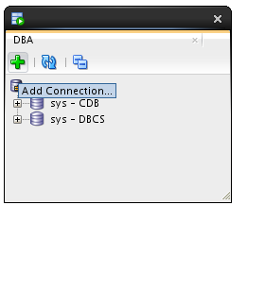

* Select the Alpha - PDB connection and click the OK button.

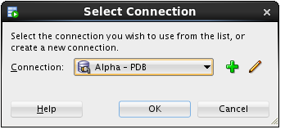

* Expand Alpha - PDB, expand Data Pump, then right-mouse-click on Export Jobs, and then select the Data Pump Export Wizard… menu item.

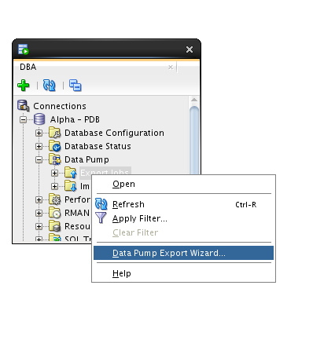

* Select the Schemas export type and click the Next button.

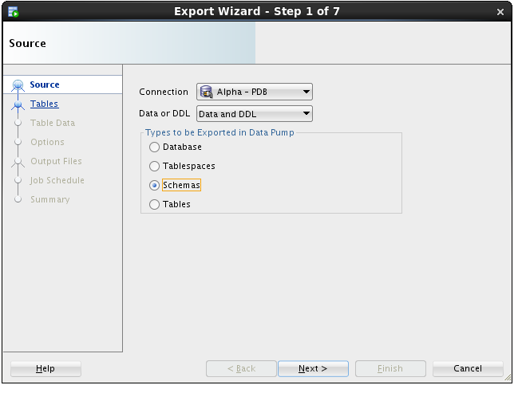

* Select the ALPHA schema and use the blue arrow to move it to the right-hand column. Click Next.

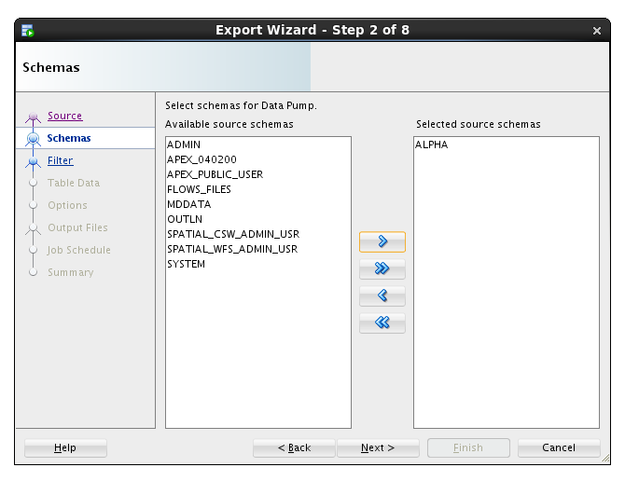

* We are not filtering out any objects, click the Next button.

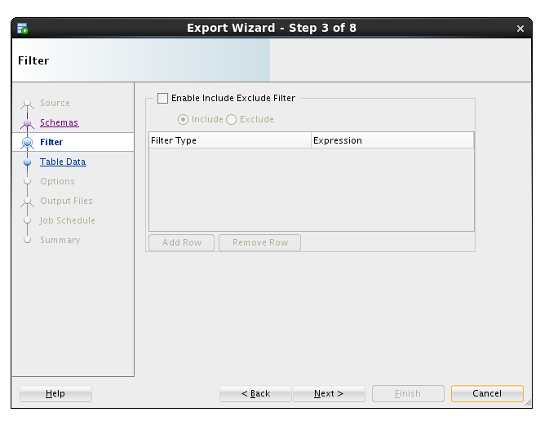

* We are not applying where clauses to table data, click the Next button.

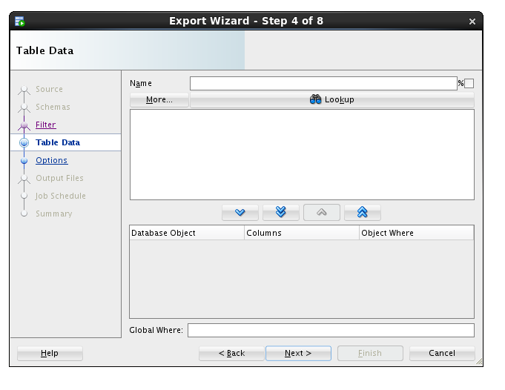

* We want a log for this export, and just like the actual export file, we must pick a directory from the list of directories in the database.
* Select ALPHA_BACKUP_DIR from the list and click the Next button.

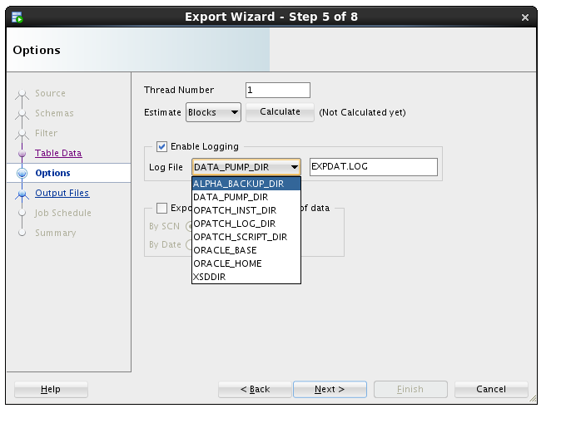

* The most important selection for any Data Pump operation is choosing the directory where the export file will be written.
* Select ALPHA_BACKUP_DIR from the Directories drop down list.
* Then, select the Delete Existing Dump Files radio button and click the Next button.

**Note**: Data Pump always uses a server side directory for all export or import operations.

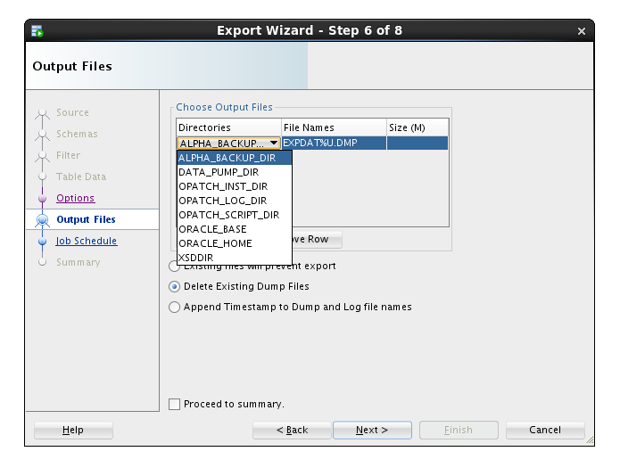

* Data Pump jobs can be scheduled to run at any time and on any desired times of the day, week or year. We will run the job immediately - click the Next button.

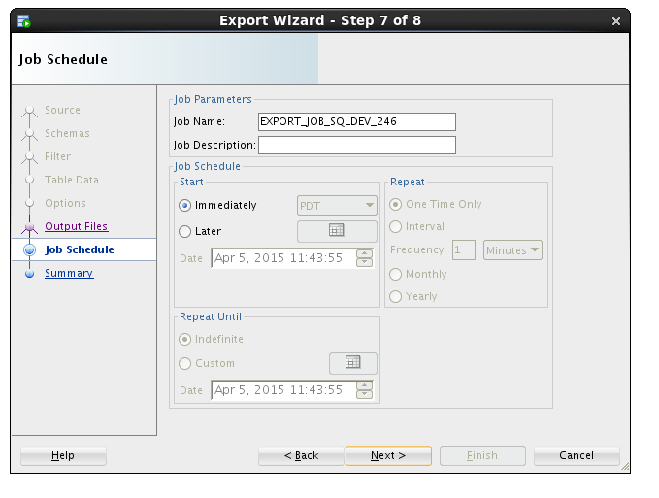

* On the Summary panel, click the PL/SQL tab to review the job definition. Review the PL/SQL use of Oracle Supplied PL/SQL subprograms for Data Pump. Click the Finish button to create the job.

|  |  |
| --- | --- |
|  |  |

* For a brief time, SQL Developer shows a progress dialog while it creates the job in the database.

**Note:** the import actually runs as a job in the database so this message is only about creating and scheduling the export.

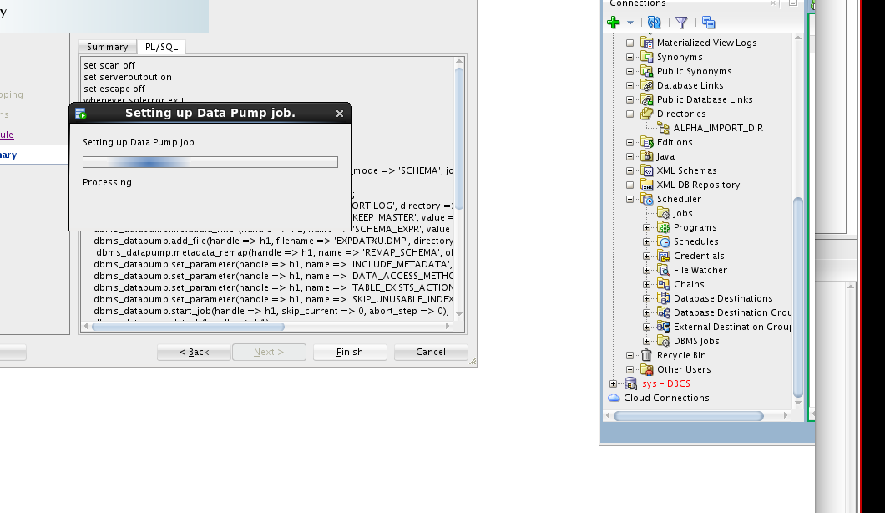

* While the job is running, you may view status information by clicking on the export job added to the DBA Navigator panel. It may take a couple of minutes so click the Refresh icon until the job is completed (NOT RUNNING).

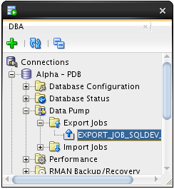 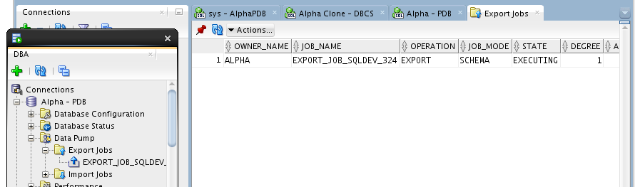

* Now we’ll copy the export Data Pump file to the server
* Start a Terminal window using the top panel icon.

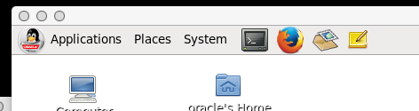

* Enter the following commands to print the working directory (pwd), list the directory (ls) contents and review the Data Pump log file.

$ pwd

$ ls

$ cat EXPDAT.LOG

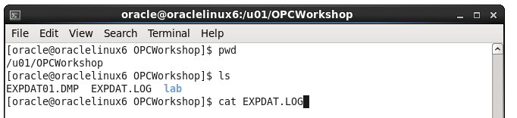

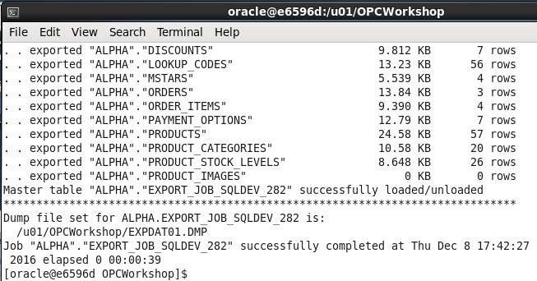

Use the following secure copy (scp) command to transfer the Data Pump export to the DBCS server. Use the Database Service Private IP address you identified in the first lab.

$ scp -i lab/labkey EXPDAT01.DMP oracle@<Alpha01A-DBCS public IP>:~

***Note:*** *the tilde (~) represents the oracle user's home directory.*

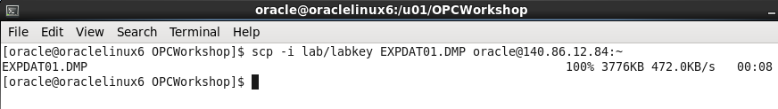

#### Import Alpha to a new Schema

* As we begin the import phase of this example we’ll first create an import directory in the Alpha Clone PDB.
* Use SQL Developer and expand the Alpha Clone - DBCS connection.
* Right-mouse-click on the Directories tree item and select the Create  Directory… menu item.

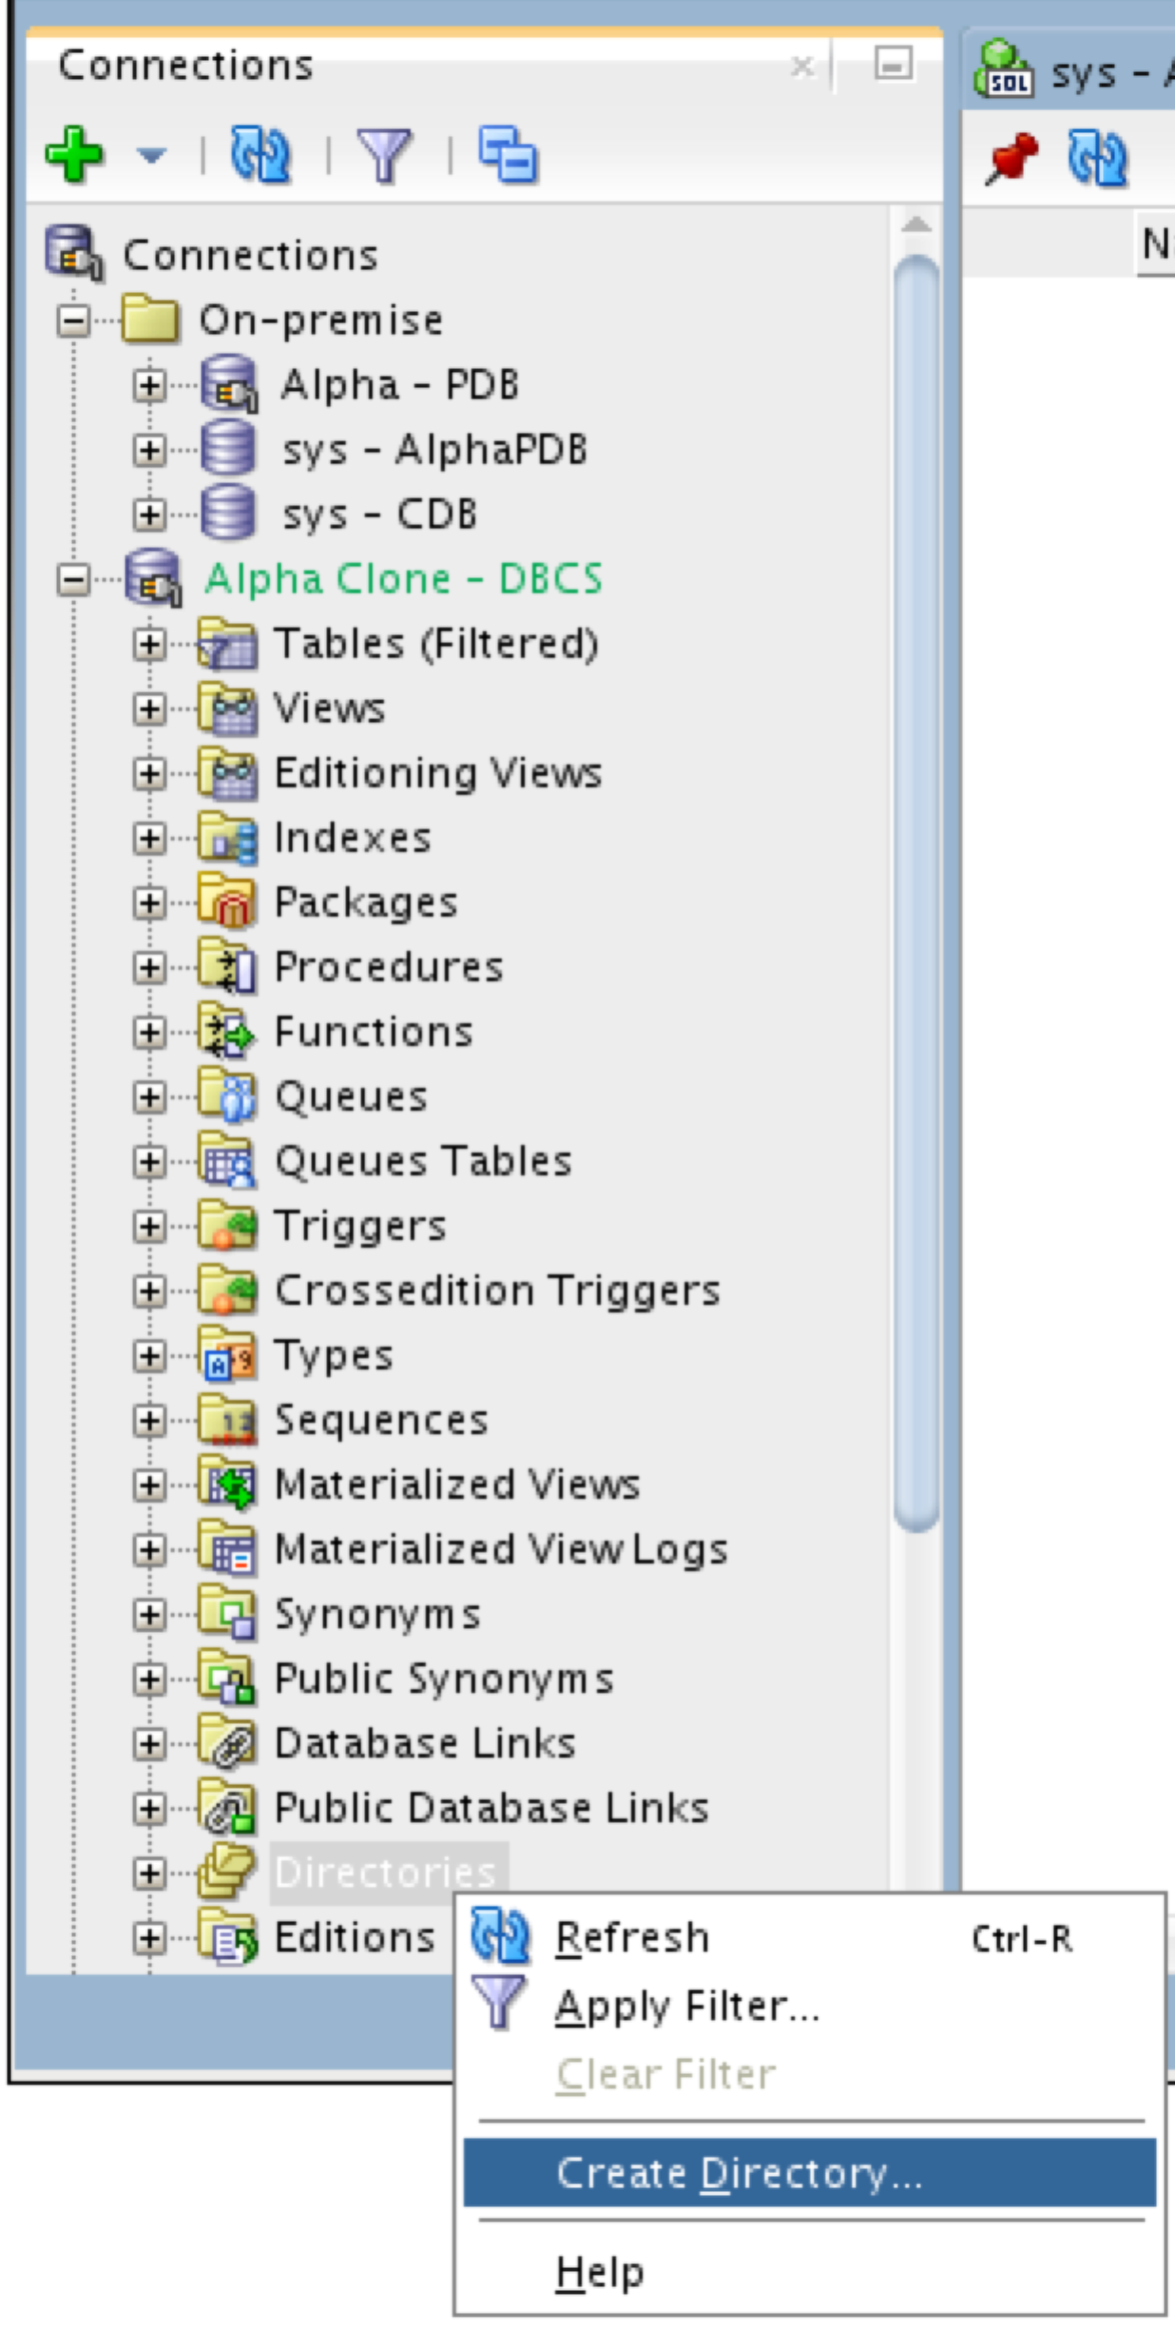

* Enter the following values and click the Apply button.
* Click OK to dismiss the confirmation message. This lets the database access the same directory where the Data Pump export file was copied.

|  |  |  |  |
| --- | --- | --- | --- |
| ***Directory Name:*** | alpha_import_dir | | |
| ***Database Server Directory:*** | /home/oracle | | |
|  | |  |  |

* The next few steps will outline creating the Data Pump Import job. To access the Data Pump features, we need to add the clone connection to the DBA Navigator.
* Click on the green plus sign, Add Connection icon on the DBA Navigator panel



* Select Alpha Clone - DBCS connection and click OK.

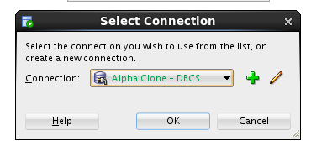

* Expand Alpha Clone - DBCS 🡪 Data Pump
* Right-mouse on the Import Jobs menu item, and select Data Pump Import Wizard… menu item.

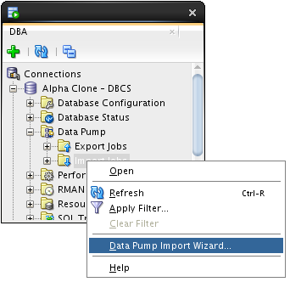

* Select Schemas from the ‘Type of Import box and Choose ALPHA_IMPORT_DIR from the ‘Choose Input Files’ drop down list, then click Next.

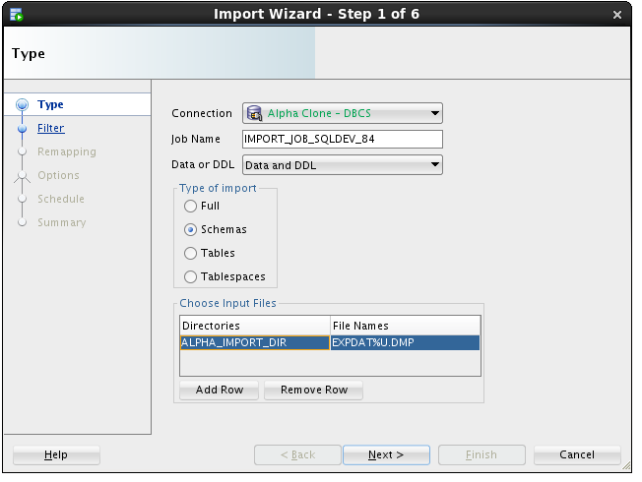

**Note:** This action might take a few minutes. There is some wait time while the database locates and scans the import file in the selected directory.

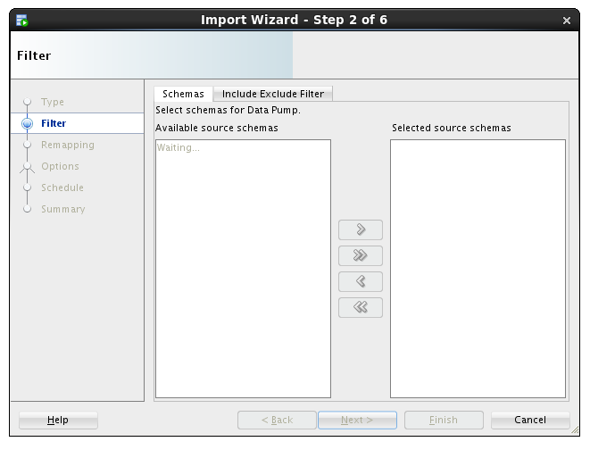

* Move the ALPHA schema from the left to the right column using the arrow button and click Next.

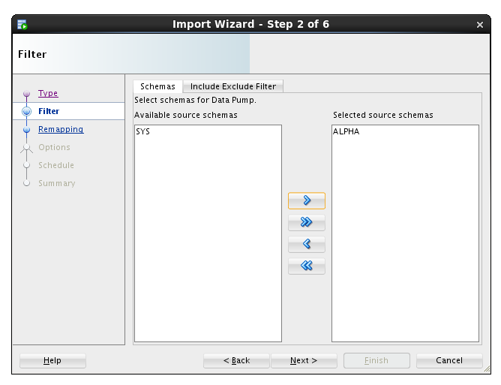

* For this lab, we are creating a new schema, so we will enter the new schema name as the destination.
* Under the Re-Map Schemas section click Add Row.
* Enter the following values and click the Next button.

|  |  |
| --- | --- |
| **Source:** | ALPHA (should be the default item) |
| **Destination:** | ALPHA_COPY |

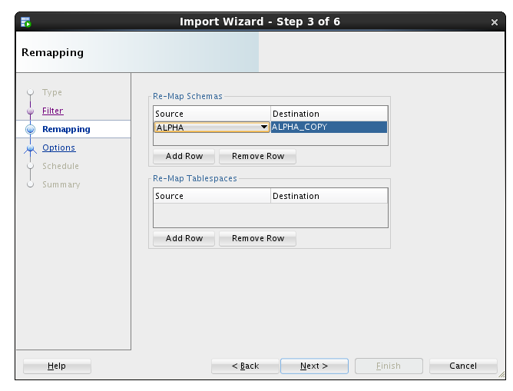

* We want to see the log output so we will select the same directory as the import file directory.
* Select ALPHA_IMPORT_DIR and click the Next button.

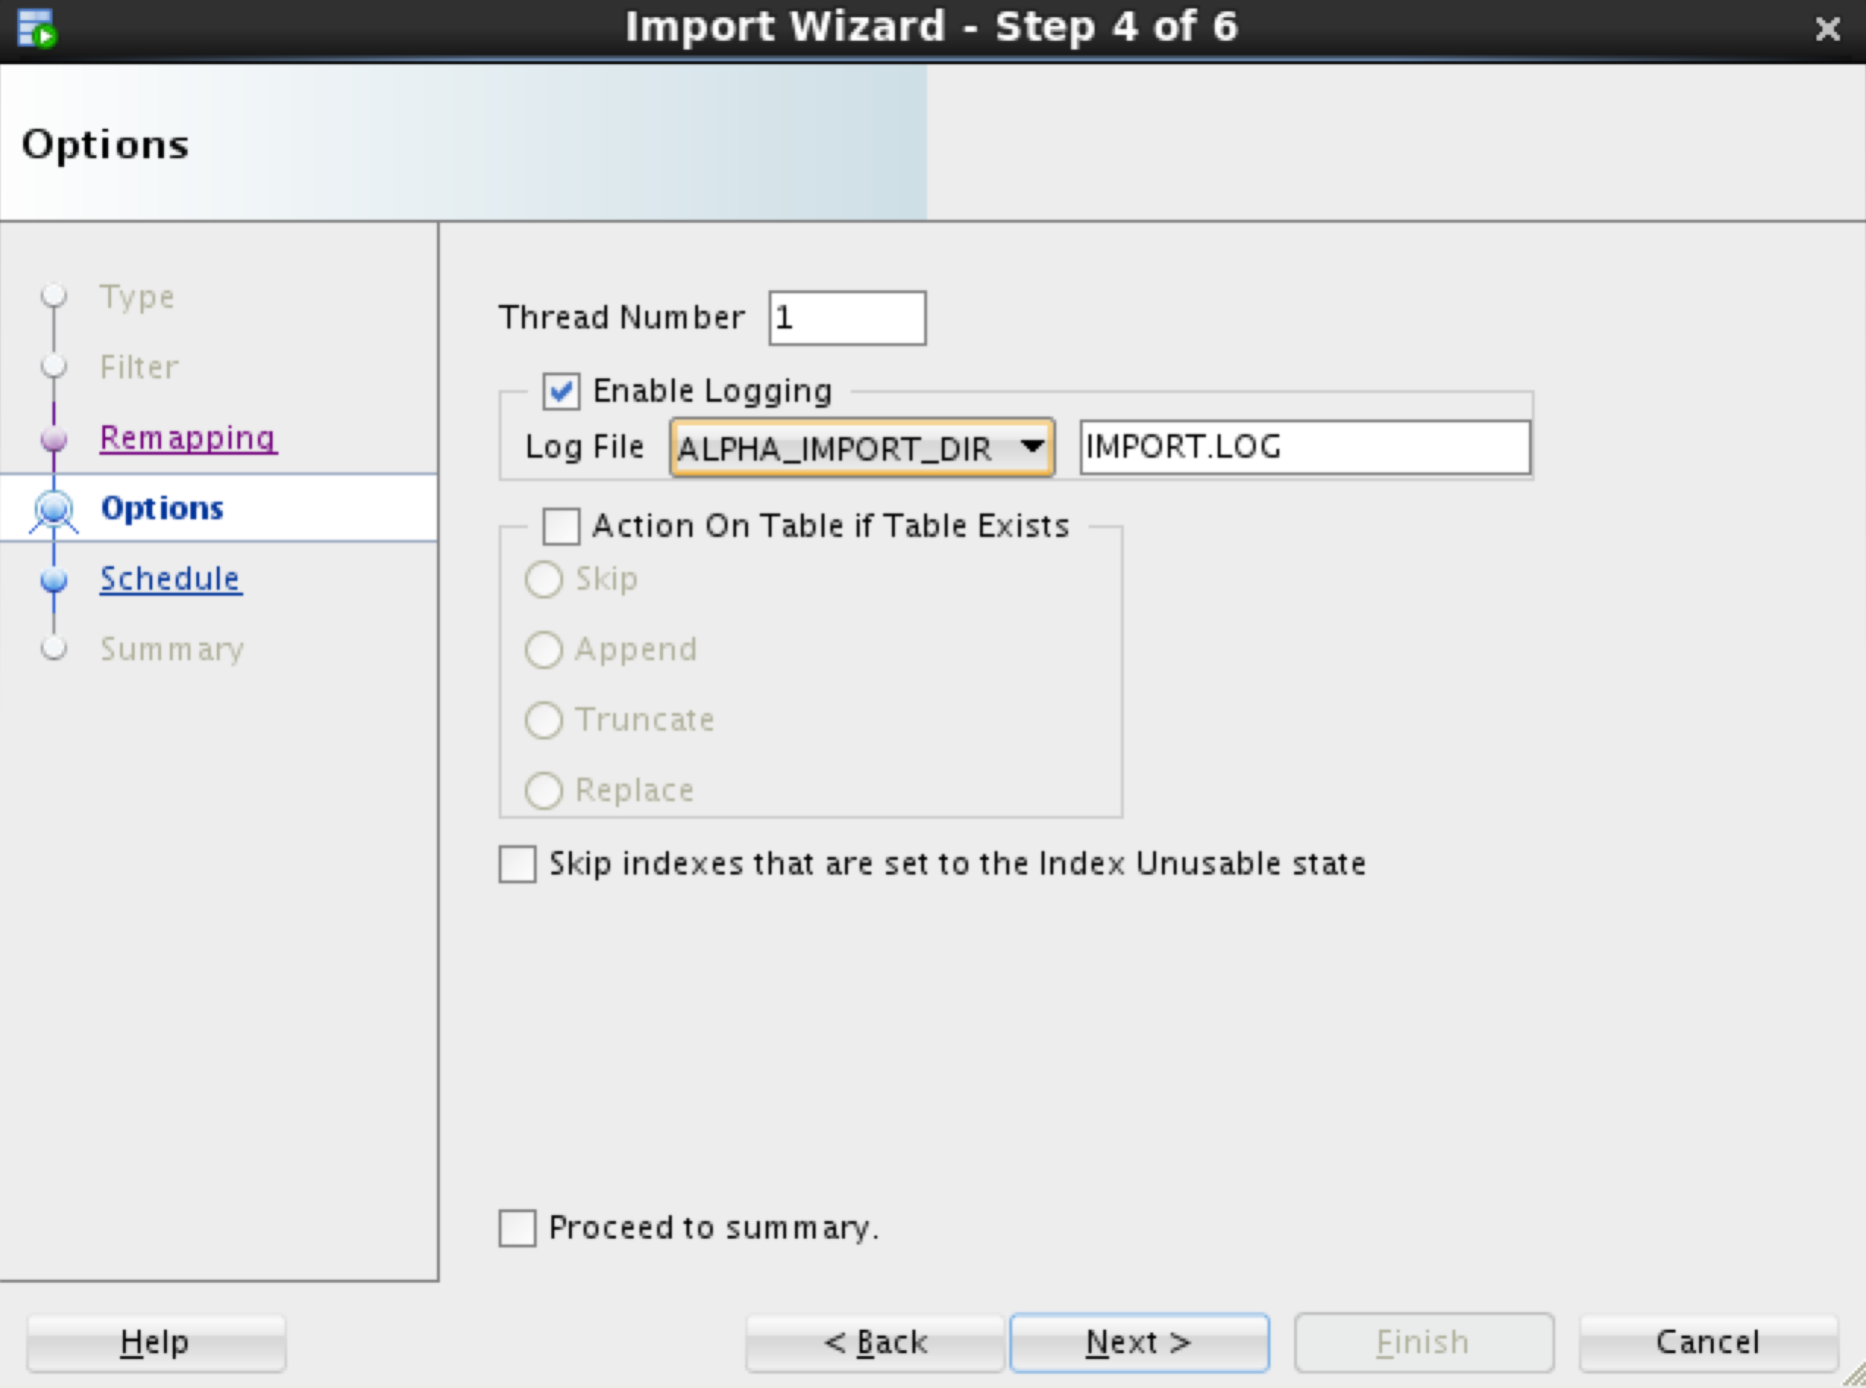

**Note:** For lab purposes we will execute the import immediately. In normal operations this job could be set up to refresh a development database on a daily basis.

* Click the Next button.

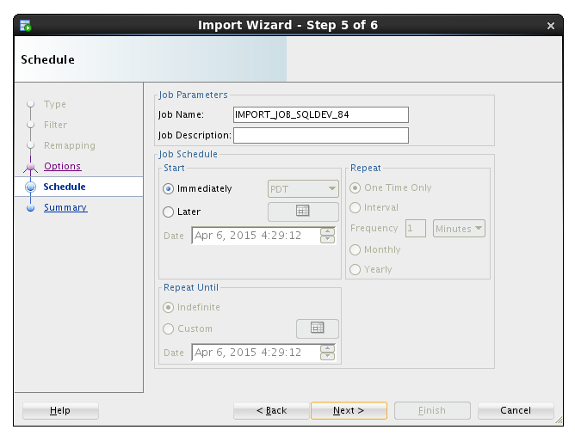

* Click the PL/SQL tab to review the small program that establishes the import job. Click the Finish button to create the job.

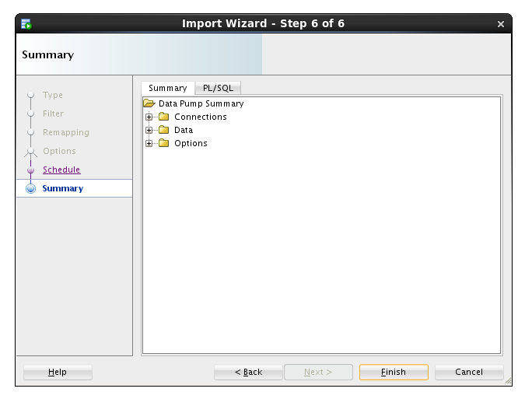 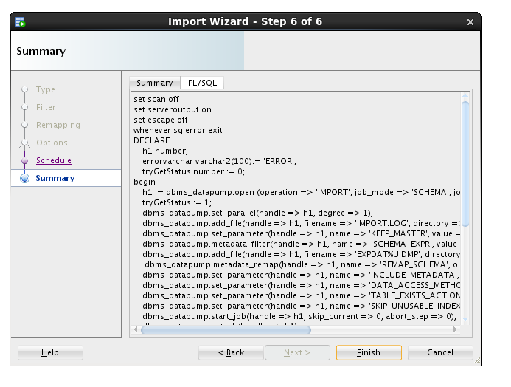

**Note:** For a period of time SQL Developer shows a progress dialog while the job is being created. The job does not run locally you’re seeing the progress of creating the job in the database.



* Locate and click on the job name to see the detailed status as the job runs. When the job completes, the database automatically removes the job. You will need to use the Refresh icon  to see when the job finishes.

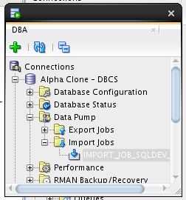 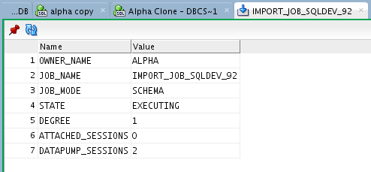

* If you are interested in verifying that the ALPHA_COPY schema is the same as the ALPHA schema, feel free to create a connection and compare.

### Cloud Migration Using SQL Developer Carts

#### Creating an SQL Developer Cart

The SQL Developer Cart is a convenient method for organizing the deployment of database objects and data from one database to another. In this trivial example, we want to update the data of just the CUSTOMERS and PRODUCTS table in the development cloud database. More elaborate usages of the cart can help package entire application deployments, including pre and post processes from multiple data sources.

* Show the Cart using the View > Cart menu option.

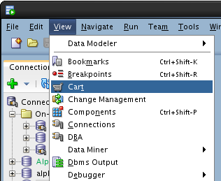

* If Cart_1 is not already created (it should be), Click on the New Cart icon.

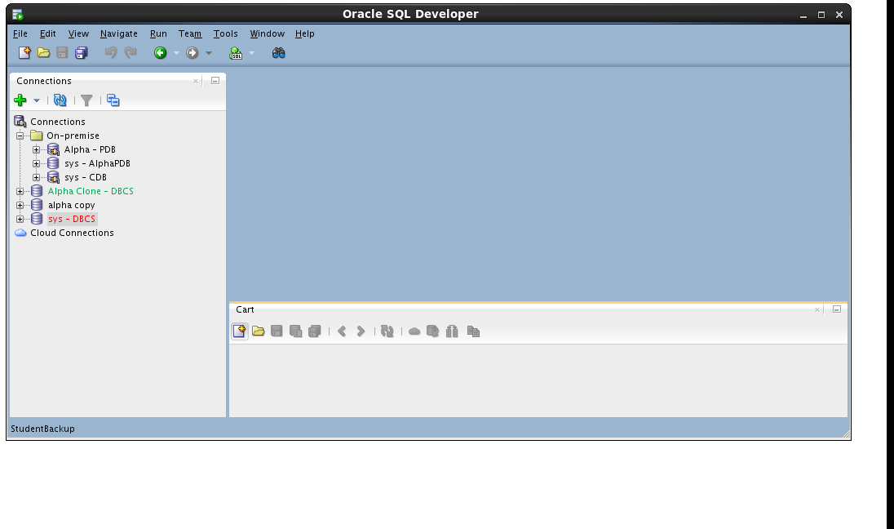

* Drag the CUSTOMERS table from the Alpha - PDB connection to the cart.

 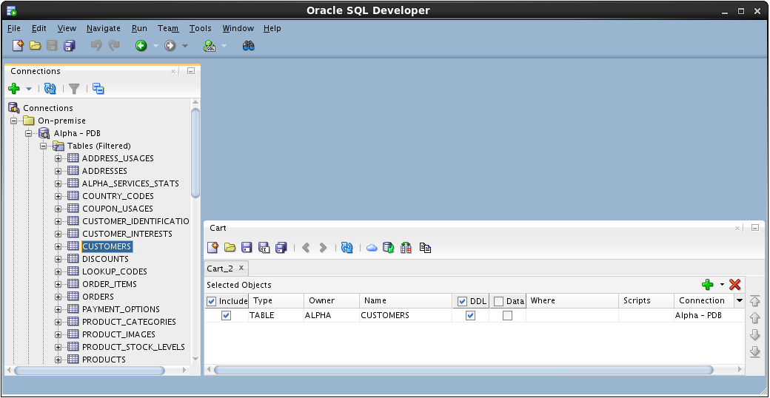

* Drag the PRODUCTS table to the cart.

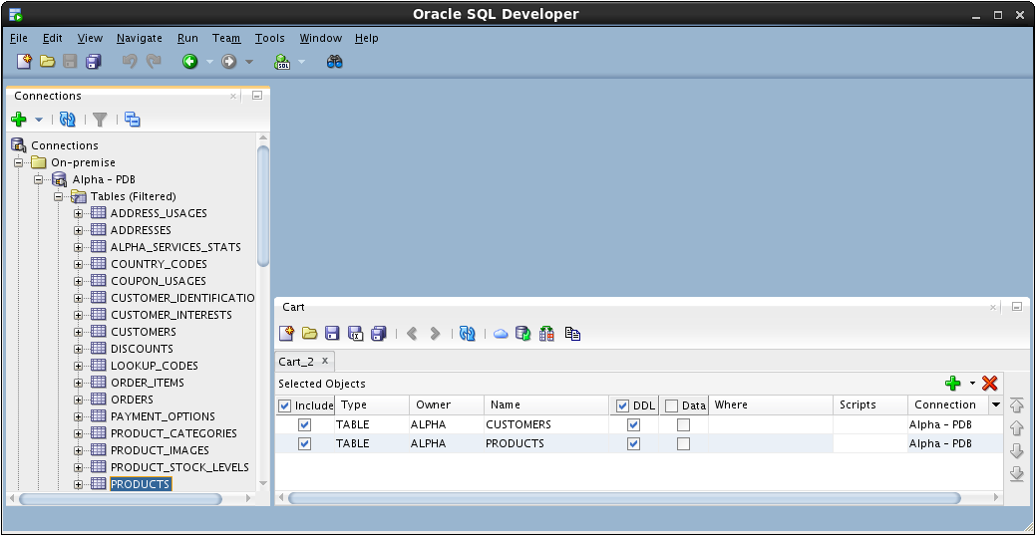

* Include a script that runs before any other Cart activity. For this lab, we are disabling all the referential integrity constraints so we can delete and insert data without regard to foreign keys on our tables.
* In the Cart window click small down arrow next to the green plus “+” icon and select Add Initial Script

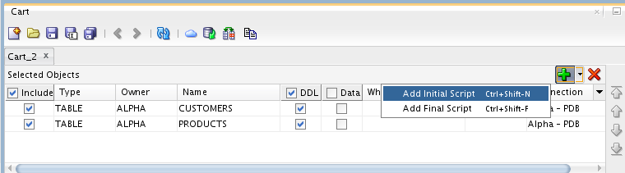

* Click the Browse… button.

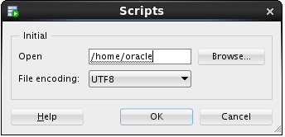

* Locate the following file and click Open:

/u01/OPCWorkshop/lab/disable-constraints.sql

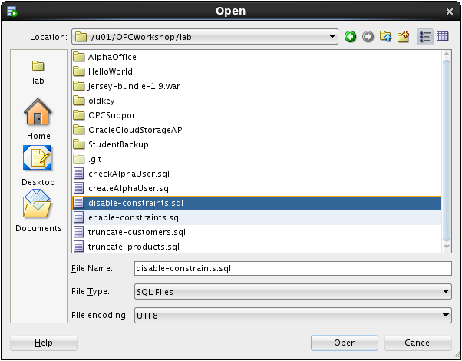

* Click OK.
* Click the down arrow next to the green plus “+” icon again and select Add Final Script which is included as the last operation performed during the cart operations.

**Note:** There can only be one Initial or Final script in a Cart.

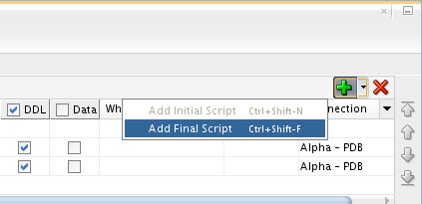

* Click the Browse… button

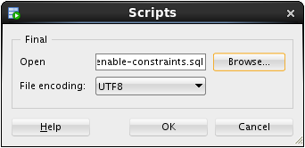

* Locate the following file and click Open:

/u01/OPCWorkshop/lab/enable-constraints.sql

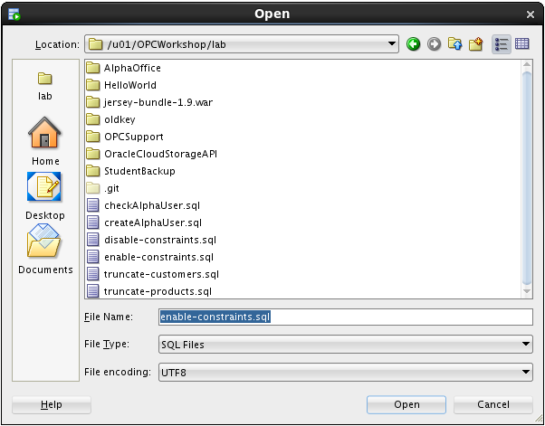

* Click OK.
* We are not creating any tables in this lab; uncheck the DDL column heading.

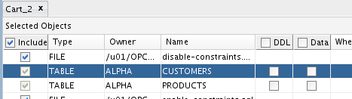

* We will move the data, include a check the Data column heading.

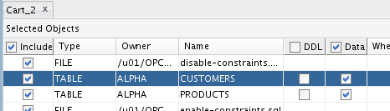

* Before we can overwrite the new rows in the CUSTOMERS table, we need to truncate the table.
* Click in the Scripts column cell for the CUSTOMERS table and then click the pencil icon.

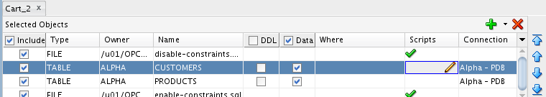

* Check the Before Load box, then click the Browse… button and select the following file:

/u01/OPCWorkshop/lab/truncate-customers.sql

* Click OK:

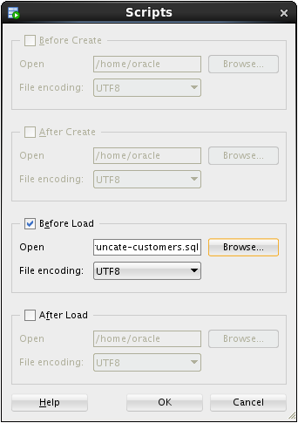

* Repeat the operation for the PRODUCTS table; click the pencil icon on the products row.

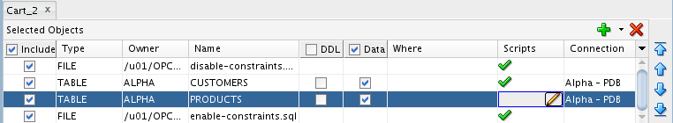

* Click the Before Load button, then click on the Browse… button and select the following file:

/u01/OPCWorkshop/lab/truncate-products.sql

* Click OK:

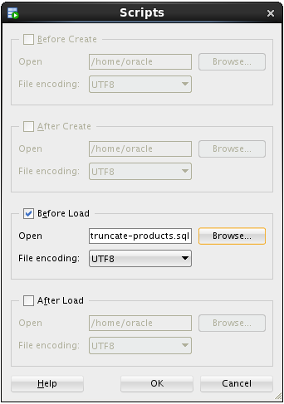

#### Export the SQL Developer Cart

* Now that the cart is complete, click the Export Cart toolbar icon to generate the script of all the elements we inserted in the cart.

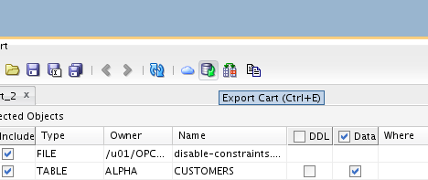

* Click the Apply button to generate script.

**Note:** The selections on this page may be saved and later reused if the cart is regularly used the same way.

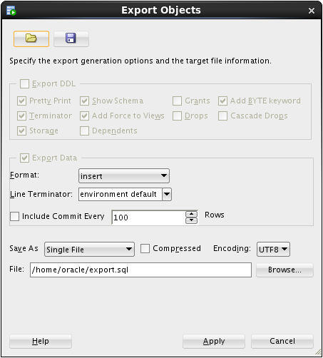

* If the file already exists, SQL Developer asks you to confirm overwriting it with new content. If you see this prompt, click the Yes button.

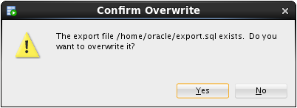

* Review the contents of the script with particular attention to the SQL statements that have been inserted based on the scripts we included.

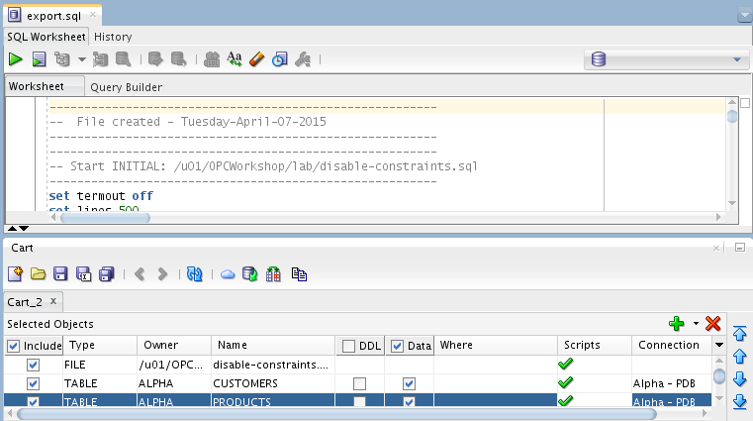

* Run the script by clicking the Run Script icon and selecting the Alpha Clone — DBCS connection.

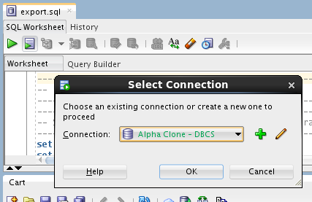

* Click OK.
* SQL Developer shows a progress bar while the script runs. Depending on your window layout, you may see the command output scrolling by while the script runs.

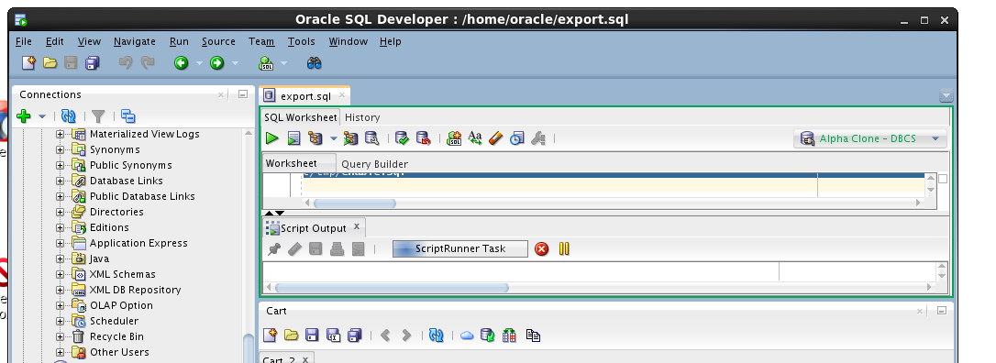

* When the script is complete, review the script output looking for the execution of both the script elements and the DML statements.

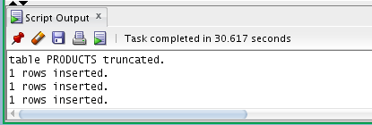

* This concludes Lab 2 – Cloud Migration, proceed to the next lab when you’re ready.

# Backup and Recovery

### Introduction

Oracle Database Backup Service (ODBS) is a new backup-as-a-service offering that enables customers to store their backups securely in the Oracle cloud. ODBS provides a transparent, scalable, efficient, and elastic cloud storage platform for Oracle database backups. The Client side Oracle Database Cloud Backup Module which is used with Recovery Manager (RMAN) transparently handles the backup and restore operations.

Oracle Database Cloud Backup Module is the cloud backup module that is installed in the database server. During the install process, a platform specific backup module is downloaded and installed. The RMAN environment of the client database is configured to use the cloud backup module to perform backups to ODBS. Using familiar RMAN commands, backups and restores are transparently handled by the cloud backup module.

### Objectives

* Install the Oracle Database Cloud Backup Module onto the VM image provided in the workshop. The database provided in the VM represents the on premise database in a typical customer situation.
* Configure RMAN to support the Oracle Database Cloud Backup Module. Then, backup the database and take a restore point to be used for Point-In-Time-Recovery.
* Simulate a destructive database operation and then restore and recover to a specific Point-In-Time.

### Lab Requirements

* VNC Viewer to access the client system

### Oracle Public Cloud Backup Recovery

#### Start the On-Premise Oracle Database

* Access the Virtual Client image following the prior instructions regarding the VNC viewer.
* If your local database is not running for some reason (it should be at this point) locate and double-click the StartDB icon.



#### Install the Cloud Backup Module

* The .jar file (opc_install.jar) used to install the Cloud Backup Module has already been placed into the /u01/OPCWorkshop/lab directory.
* Open a Terminal Window, cd into the lab directory and execute the following OS commands to verify that opc_install.jar exists.

$ cd lab

$ pwd

$ ls *.jar

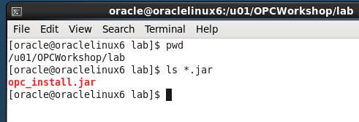

* The installation command with all of the options is rather lengthy. In order to make things easier for you and eliminate potential typos the installation command has been saved into a text file named Workshop_Commands_URLs.txt. The file is represented by an icon on the Client Image Desktop.
* Double click on the Workshop_Commands_URLs.txt icon to open up the file.

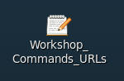

* Find the “**OPC Cloud Backup Installation**” section in the text file.
* Replace <opc-identity-domain> <opc-username> and <opc-passwd> (including replacing the <>) with the **Identity Domain, Username, and Password** student account information you were assigned. Also, be sure to put single quotes around your password to avoid any issues with special characters.
* Before:

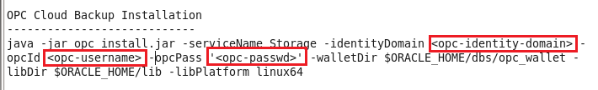

* After

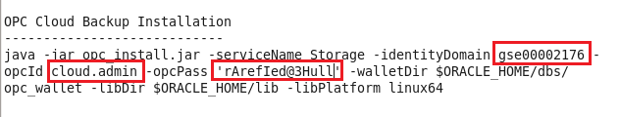

* Copy and Paste the updated command from the text file into your terminal and hit Enter.

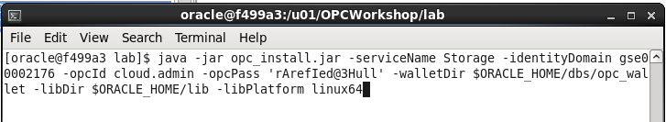

* The installation command creates a configuration file “**opcorcl.ora**” and wallet directory “**opc_wallet**” and places these in $ORACLE_HOME/dbs. It also downloads a library file “**opclib.so**” that RMAN uses to communicate with the Oracle Database Backup Service and places that in $ORACLE_HOME/lib. You specified these locations in the syntax of the install command.

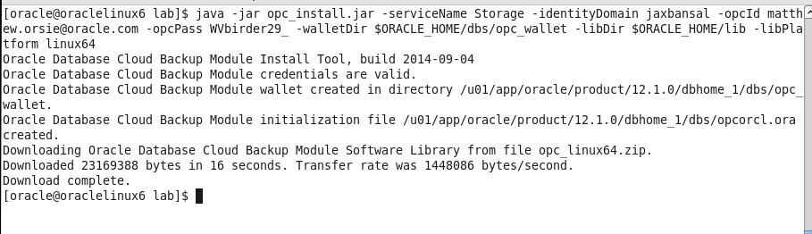

* Verify the required files have been created by entering the following commands

$ ls $ORACLE_HOME/lib/libopc*

$ ls $ORACLE_HOME/dbs/opc*

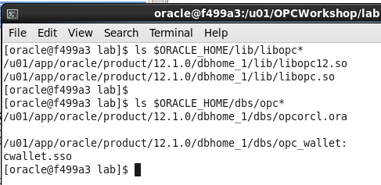

#### Configure RMAN to support Cloud Backups

Before we can do backups to the Cloud storage location in your account, you need to configure a number of RMAN properties. These properties define:

* How long to retain the backups (30 days)
* Setting up a device type called “sbt_tape” that uses the library and config files you just installed.
* Note that any defined storage chunks in the cloud will have names starting with “alphacloud_”
* Turning on Encryption for data security. This is mandatory for an on premise to cloud backup scenario
* Set a degree of parallelism so that the backup/restore uses multiple threads. This is for performance.
* Setting backup optimization to ON so that RMAN will not unnecessarily transfer data to and from the cloud. (e.g. If a backup file is already present and has not had any changes before a “new” backup is performed, this file will not be dealt with, saving time).
* Setting a compression level for the files going to/from the cloud
* Configuring the sbt_tape device as the default for all backups
* Connect RMAN to our local database using rman target /

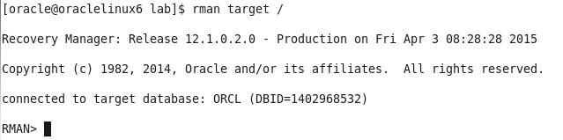

* Commands in RMAN can be run in blocks so you can do a sequence all at once.
* Copy and Paste from the entire run block in Workshop_Commands_URLS.txt under the RMAN Config Params section as shown below:

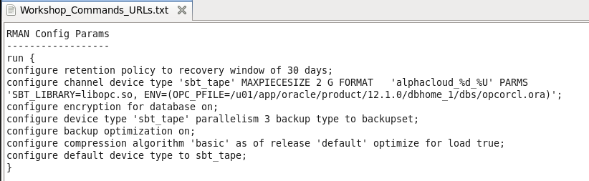

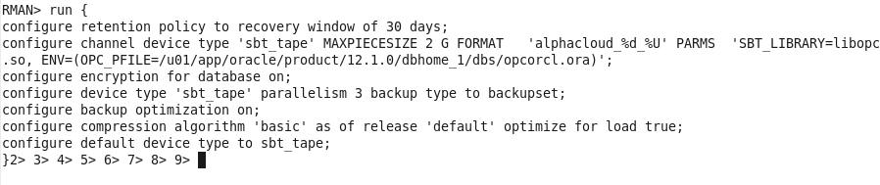

* Hit Enter and the parameters will be set to the following:

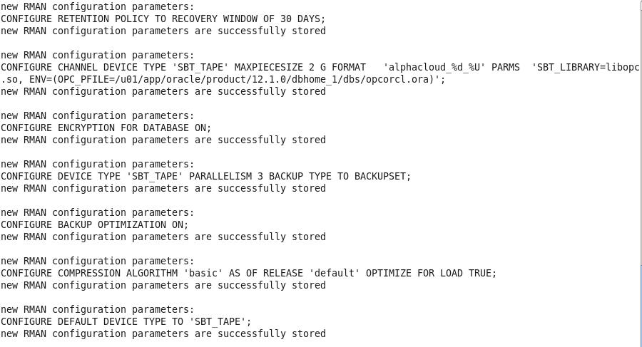

* Verify the changes in RMAN by typing show all;

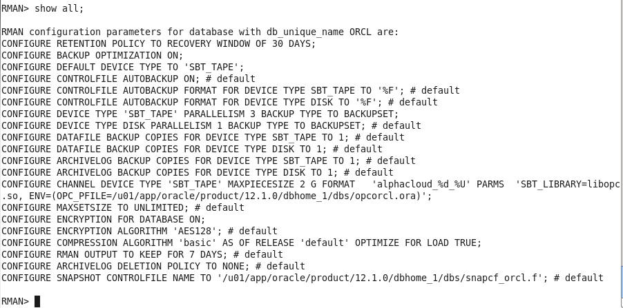

#### Backup the On Premise Database

For backup and recovery we would usually run the following sequence of commands from a shell script or an RMAN run block, but for lab illustration purposes we’ll copy and paste each individual command in sequence so you can get a better feel for what is going on.

* Under the RMAN FLOW 🡪 BACKUP section of the Workshop_Commands_URLS.txt file Copy the first line under the word BACKUP and paste it into your RMAN terminal session.

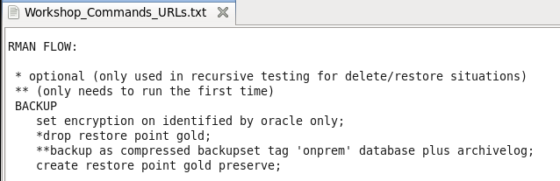

* RMAN> set encryption on identified by oracle only;

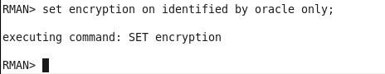

* For security reasons, backing up to the Oracle Public Cloud requires that encryption is used. The options are Transparent Data Encryption (TDE) and/or password encryption. We will be using password encryption in this lab.
* Copy and Paste the backup command (minus the asterisks)
* backup as compressed backupset tag 'onprem' database plus archivelog;
* The backup will commence. Depending on the speed of your network the backup job will take just a few minutes. The database control files and SPFILE are the last part to be backed up.

**NOTE:** If for some reason your backup does not finish properly because of network issues, there is a way to clean up the partial backup files and retry. This procedure is documented in the **Appendix** at the end of this lab.

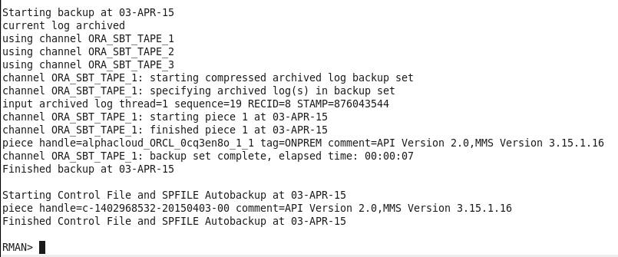

* When creating a backup, the file chunks are placed in a user defined storage container in your account, OR they will be in a system generated container called oracle-data-storage-xxx. We can verify that the backup actually went to the cloud once the backup command has completed.
* You can use the RMAN list backup summary command to verify the backup files. Type the following command into the RMAN terminal session.
* list backup summary;

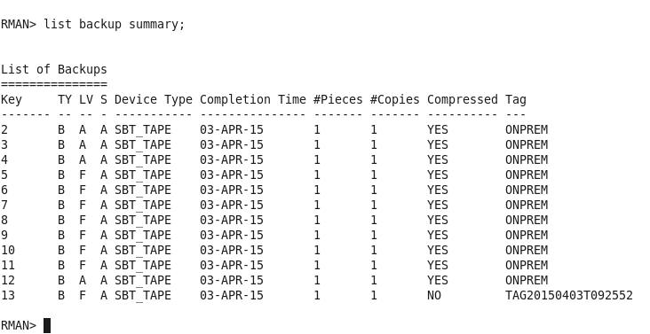

* Enter the following command at the RMAN prompt**:**
* create restore point gold preserve;

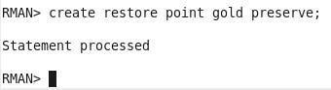

#### Oops…

* Now that we have a backup of our database we are going to “accidently” drop a table that will reappear once we perform the restore.
* Open up a new Terminal Window and use SQL*Plus to connect to the **alpha schema** in the local AlphaPDB container database.

$ sqlplus alpha/oracle@alphapdb

* There is a table called **mstars** in the schema. Query the table to view the contents.

$ select * from mstars;

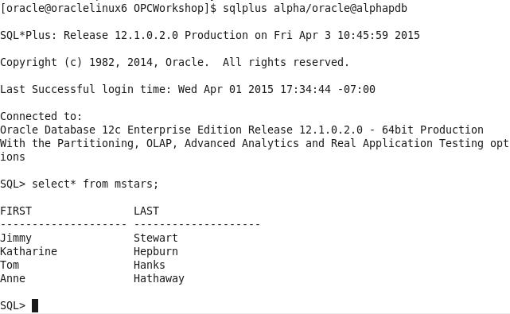

* Drop the table with the drop table command

SQL> drop table mstars;

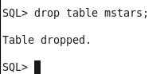

* Exit SQL*Plus
* SQL> exit;

#### Restore and Recover the Database to a Point in Time

* In order to recover from the accidental table drop, we now need to restore the database to the point in time before the mstars table was accidentally deleted. We’ll use the cloud backup files to perform this restore.
* Open the RMAN session you used in the previous steps. If you’ve exited out of RMAN, it can be started again by entering the following within a terminal window:

$ rman target /

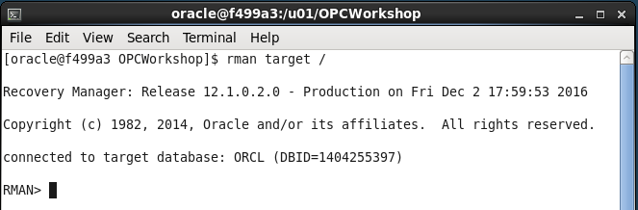

Type the following commands to ready the database for a media recovery.

RMAN> shutdown immediate;

RMAN> startup mount;

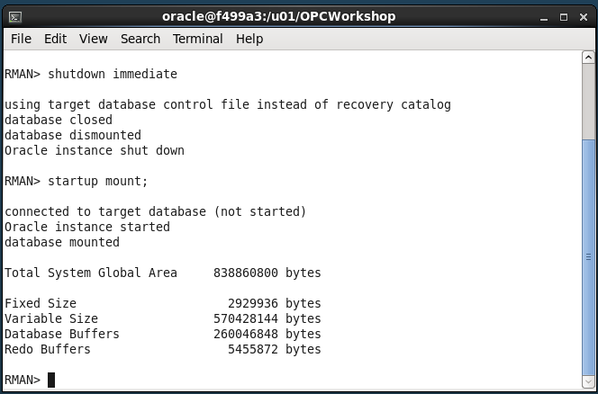

* The next few steps will bring the entire database to a point where media recovery can occur. This takes the database offline. If you had multiple PDBs in the database and only needed to recover data in one PDB while leaving the others on-line, you could use the steps listed in the ALTERNATIVE RESTORE section in Workshop_Commands_URLS.txt under the RMAN FLOW heading. It takes a little longer using the ALTERNATIVE RESTORE method, so we’ll use the flow under the RESTORE section.
* Set the decryption user name by typing or copying the following command from within the RESTORE section of the Workshop_Commands_URLS.txt file.

RMAN> set decryption identified by oracle;

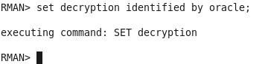

* Copy the run block and Paste it into the RMAN terminal session. The run command will perform the restore / recovery to our “gold” restore point. The final step opens the database and resets the logs since we’ve restored to a previous point in time.

RMAN> run {

restore to restore point gold database;

recover database to restore point gold;

alter database open resetlogs;

}

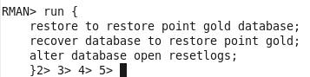

* Press Enter and the commands will be executed:

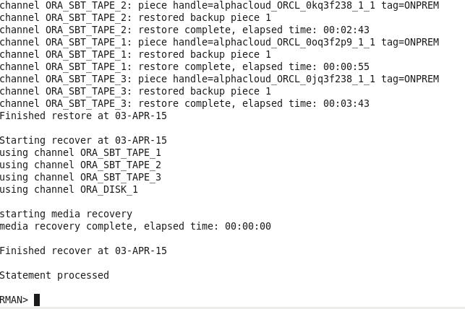

* Once the script completes, return to the Terminal Window that was used to connect with SQL*Plus and connect back into the AlphaPDB container as alpha/oracle and run a query to see if the mstars table has been recovered.

$ sqlplus alpha/oracle@alphapdb

SQL> select * from mstars;

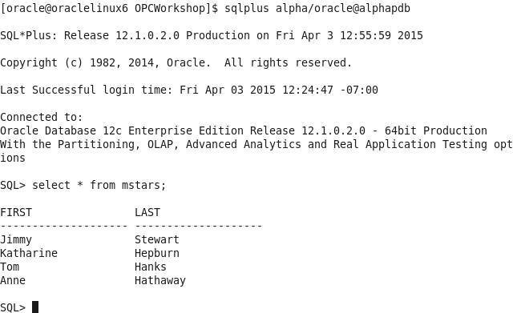

This concludes lab 3 – Backup and Recovery. Proceed to the next lab when you’re ready.

**Appendix**

* In case your backup does not complete properly you can clean up the partial backupset and rerun the backup. You may have to wait a few minutes after the backup failure before the partial backup files can be deleted.
* Start up RMAN and type:
* RMAN> delete noprompt backupset tag ‘onprem’;
* Rerun the backup
* RMAN> backup as compressed backupset tag 'onprem' database plus archivelog;

# Database Development

### Introduction

In this lab you will deploy an APEX application to the Alpha Clone PDB and adjust the firewall rules to support access to the application from the Internet using a PC based browser or mobile device.

### Objectives

* Enable APEX in the Alpha Clone PDB.
* Create APEX REST services
* Deploy and access an Alpha Office APEX application.

### Lab Requirements

* The following lab assume that the steps outlined in lab guides 100 and 200 have been completed.
* VNC Viewer for access to the cloud client image
* The SSH tunnels must be active in a terminal window.

### Alpha Office and APEX

#### APEX Workspace Administration

The Alpha Clone database contains an unused APEX configuration. As the first part of this lab we will complete the configuration of the cloned database APEX configuration.

**Note:** The standard install of APEX for a 12c database created many objects shared by both the container and pluggable database but user and password information is always local to the database we access. In other words, the APEX password we set in Lab 100 has not been in the cloned database.

* Make sure the SSH tunnels you set up in lab 100 are still active in your terminal window, if not refer to lab 100 to set up the SSH tunnels.
* During the plug-in operation, many of the common objects in the pluggable database were evaluated by the database and some changes were made to the new database to work with its new container. One of these adjustments was locking the database accounts used to provide REST services. We will need to unlock the APEX_LISTENER and APEX_REST_PUBLIC_USER accounts.
* If it’s not already running, startup SQL Developer from the Cloud Client desktop on the VNC connection.
* Open the DBA Window and locate the Alpha Clone - DBCS item (created in Lab 200) in the **DBA Navigator**
* Expand it and click on the Security🡪Users item.

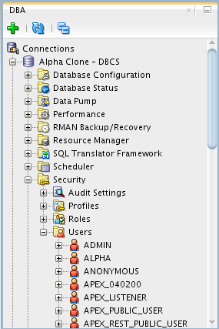

* Right-mouse on APEX_LISTENER and select Unlock User…

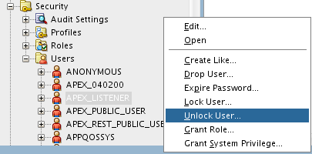

* Click the **Apply** button to unlock APEX_LISTENER. You may also use the SQL tab to review the unlock statement.

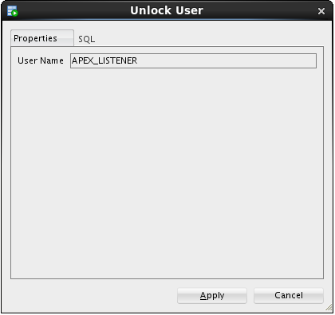 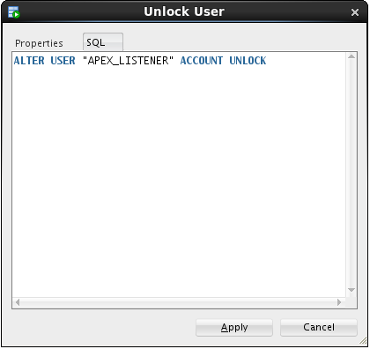

* Repeat the Unlock User… operation for the APEX_REST_PUBLIC_USER.

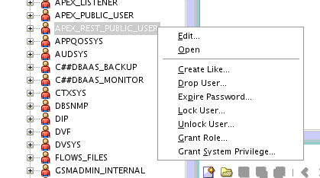

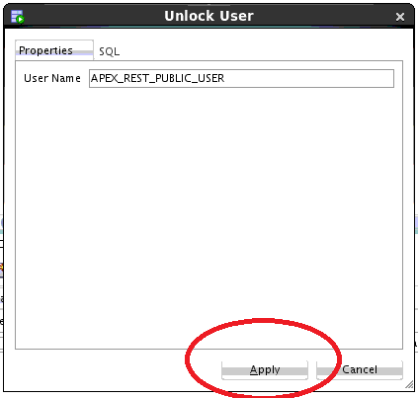

#### Create the Alpha Office workspace

* In the **Chrome** browser, open up a new tab and test the updated rule by accessing the APEX instance in the container database from the Internet. Use the Public IP address from the cloud instance we created in the first lab.

**Note:** Be sure to use the https protocol.

**https://<your-Public-IP>/apex/alphaclone/apex_admin**

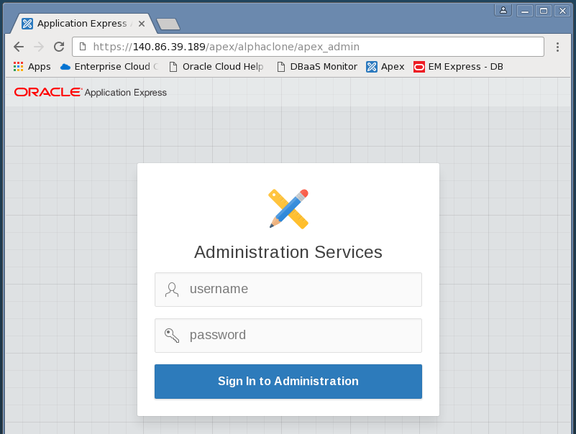

* After you’ve accepted the SSL certificate and see the APEX administration page, enter the following admin credentials and click the Login to Administration button:

|  |  |
| --- | --- |
| **Username:** | admin |
| **Password:** | Alpha2014_ |

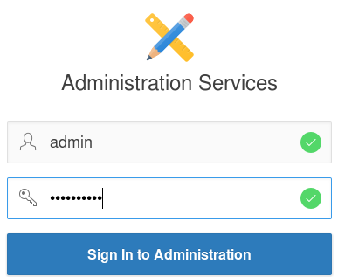

* You **may** be prompted to change the ADMIN user password, if not, skip to the next step. These credentials apply to the APEX objects local to the pluggable database. For convenience, we will enter the same password as the container database.
* Enter the following values and click the **Apply Changes** button.

|  |  |
| --- | --- |
| **Enter Current Password:** | Alpha2014_ |
| **Enter New Password:** | Alpha2015! |
| **Confirm New Password:** | Alpha2015! |

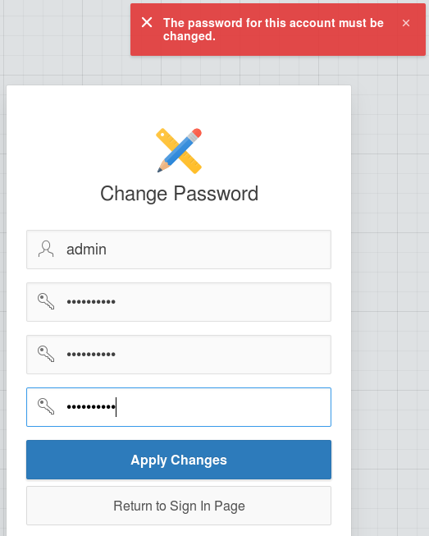

* After logging in successfully, feel free to click around in the APEX interface to get familiar with it.
* When you’re ready to begin, click the Create Workspace button

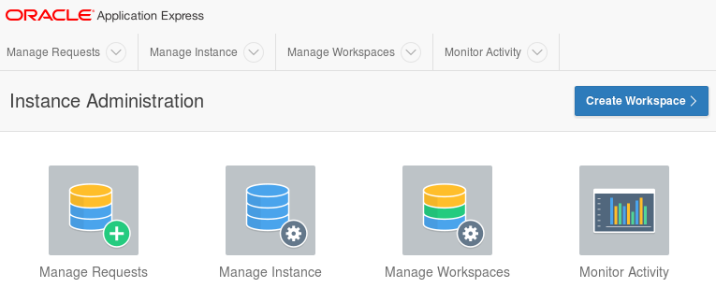

* At the Identify Workspace dialog, enter the following workspace name and click the Next button.

|  |  |
| --- | --- |
| **Workspace Name:** | AlphaDev |

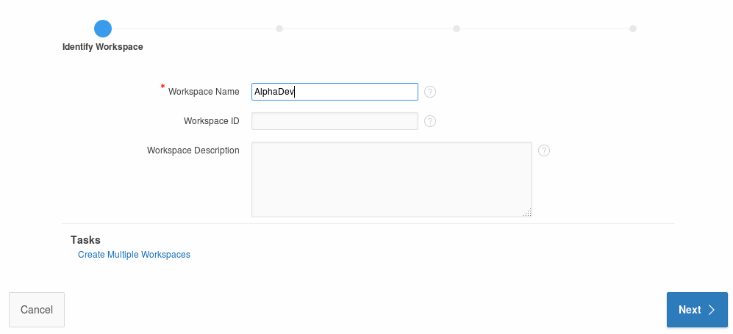

* At the Identify Schema dialog, select and enter the following values followed by the Next button.  
    
  **Note:** Use the search icon 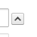 to find the ALPHA schema.

|  |  |
| --- | --- |
| **Re-use existing schema?** | Yes |
| **Schema Name:** | ALPHA |

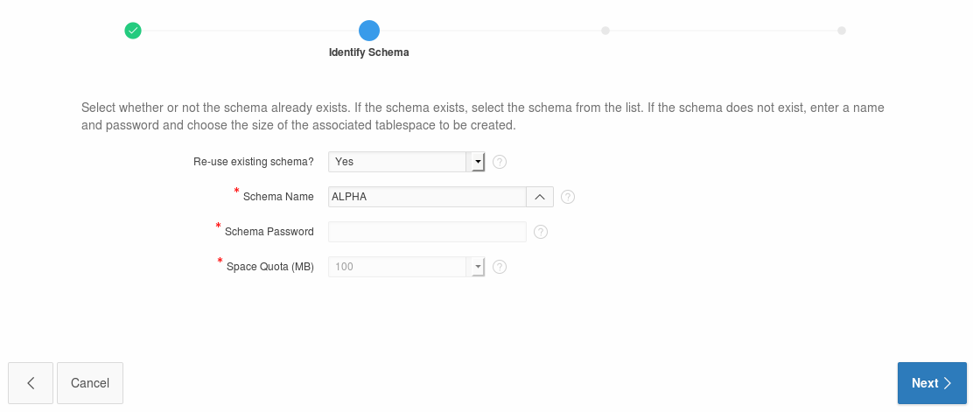

At the Identify Administrator dialog, enter the following values and click the Next button.

|  |  |
| --- | --- |
| **Administrator Username:** | ADMIN |
| **Administrator Password:** | Alpha2014_ (May be prompted to change) |
| **Email:** | dummy@localhost.localdomain |

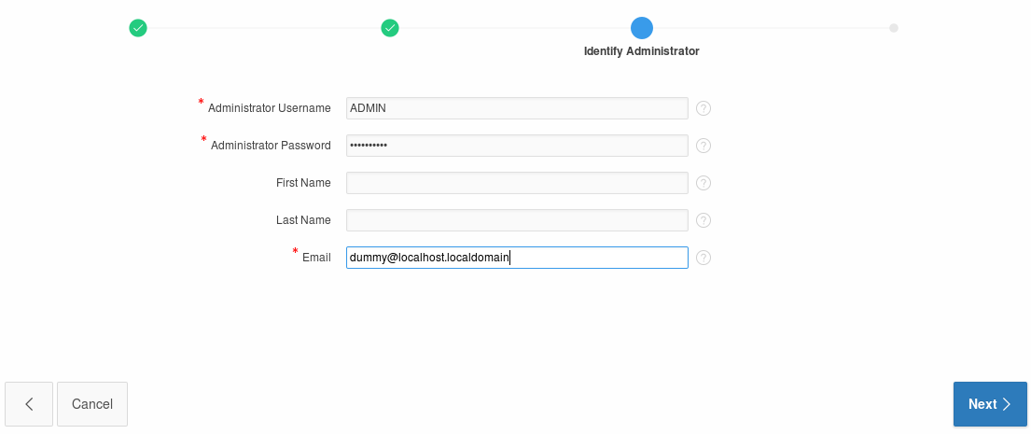

* Review the selections on the Confirm Request page and then click the Create Workspace button.

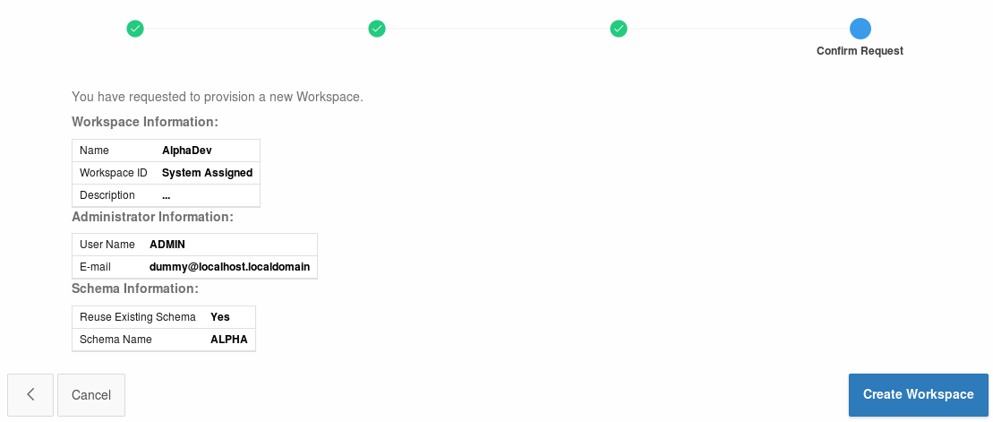 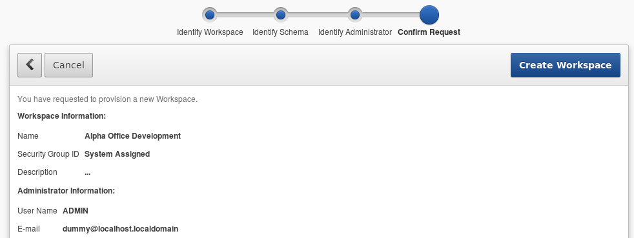

* APEX will display the ‘Workspace Created’ message
* Click Done

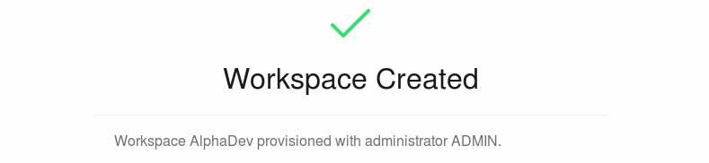

* Click the ADMIN dropdown in the upper right and select Signout

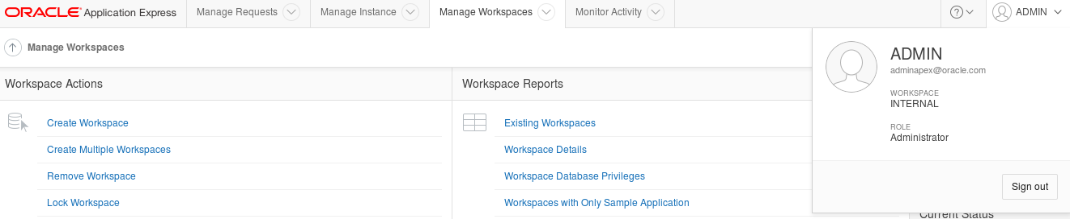

* Click the Return to **‘Sign In Page’** to continue



#### Build REST services

* Login to the Alpha Office APEX development workspace using the following credentials.

|  |  |
| --- | --- |
| **Workspace:** | AlphaDev |
| **Username:** | ADMIN |
| **Password:** | Alpha2014_ |

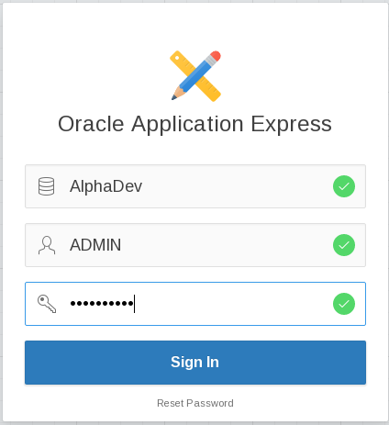

* You **may** be prompted to change your password. Enter the following values and click the Apply Changes button.

|  |  |
| --- | --- |
| **Enter Current Password** | Alpha2014_ |
| **Enter New Password** | Alpah2015! |
| **Confirm New Password** | Alpha2015! |



* Once you’ve logged in successfully, click the SQL Workshop button.

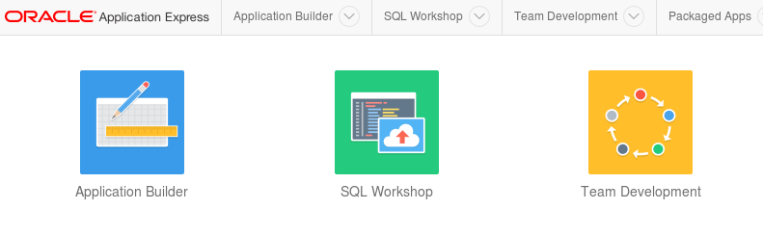

* Click the RESTful Services button.

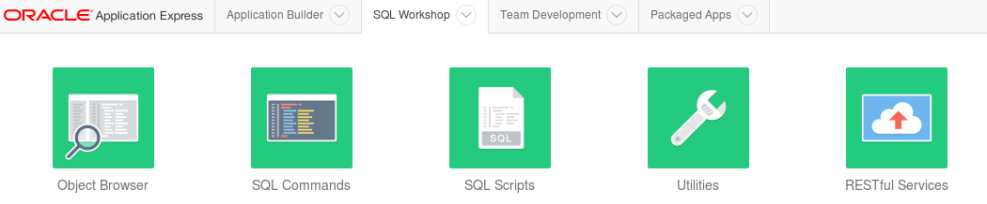

* Click the Create > button

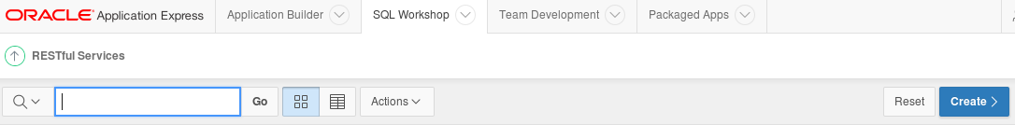

* There are three sections on the RESTful Services page:
* Restful Services Module
* Resource Template
* Resource Handler

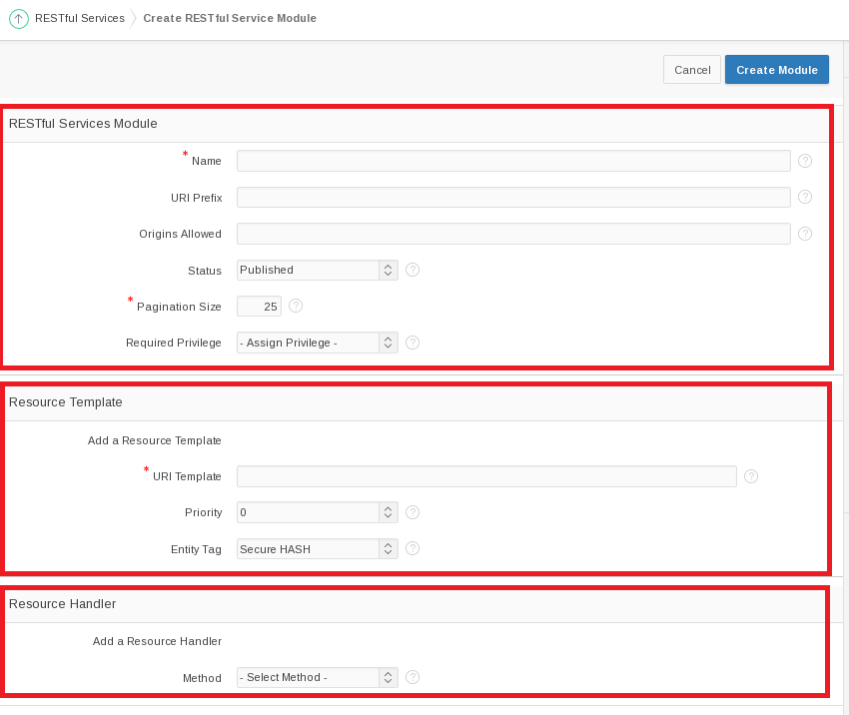

* Fill out the information for these sections using the information provided below.
* For the **RESTful Services Module** section, use the following values:

|  |  |
| --- | --- |
| **Name:** | alpha.office |
| **URI Prefix:** | alphaofc/ |

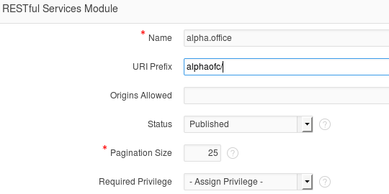

* In the **Resource Template** section enter the following value:

|  |  |
| --- | --- |
| **URI Template** | products/ |

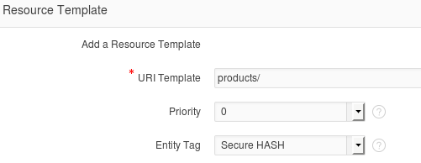

* For the last section titled **Resource Handler** use the following values:

|  |  |
| --- | --- |
| **Method:** | GET |
| **Source Type:** | Query |
| **Format:** | JSON |
| **Source:** | select * from products |

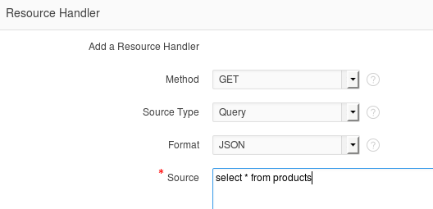

* Click Create Module to complete the REST service creation.

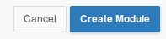

* APEX will show the new service module with a confirmation message.
* Click the GET handler for our template in the folder structure on the left of the screen.

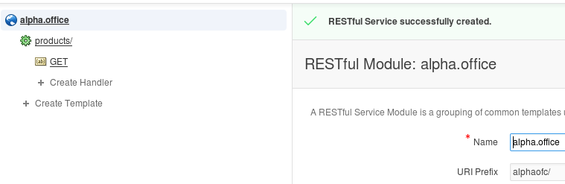

* Review the definition.
* Since this operation has no parameters, we can easily test it by clicking the Test button.

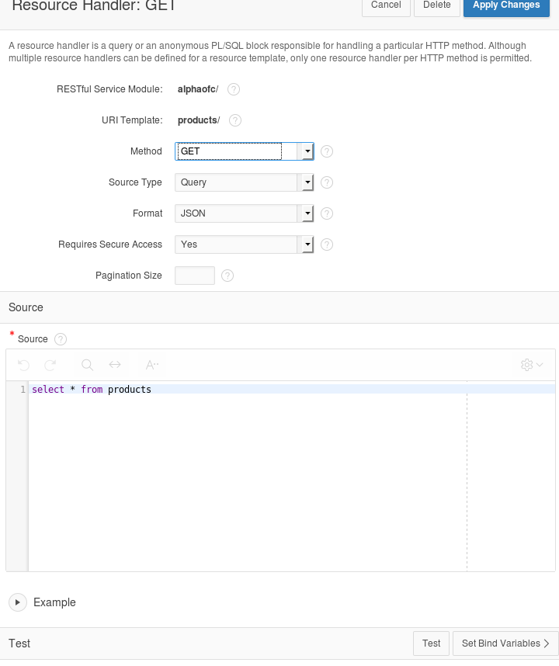

* Review the JSON produced by the service.
* Click the browser's back button to return to the APEX page.

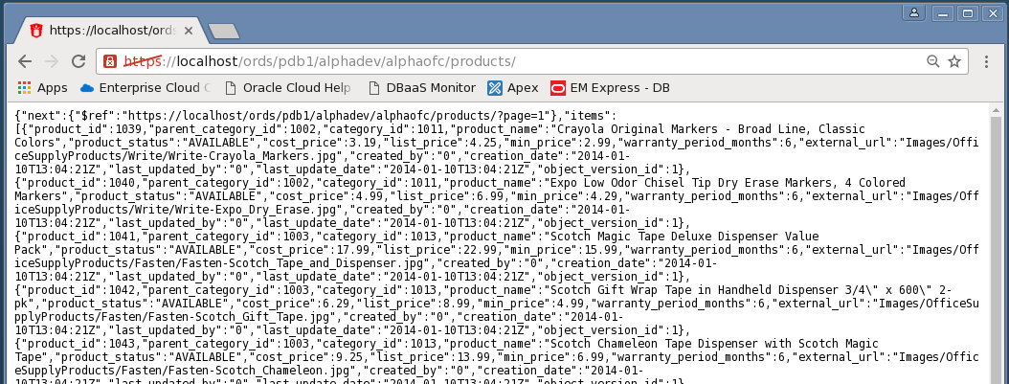

#### Create a Parameterized REST Service

* In the next section we will create a REST service that takes a product number and returns only one database row as a JSON object.
* Click the Create Template link.

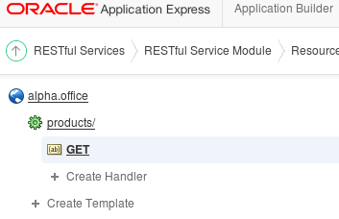

* Enter the following URI Template.

**Note:** The {id} syntax indicates the REST call accepts one parameter named "id" - this is automatically available in later for SQL queries.

* When the entry is complete, click the Create button.

|  |  |
| --- | --- |
| **URI Template:** | product/{id} |

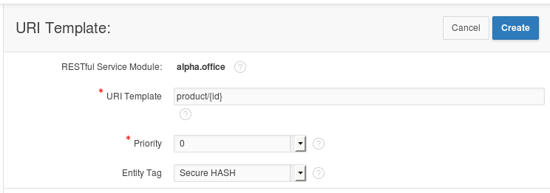

* APEX displays a success message for the new template
* Click the Create Handler link under the product/{id} template on the left side of the screen.

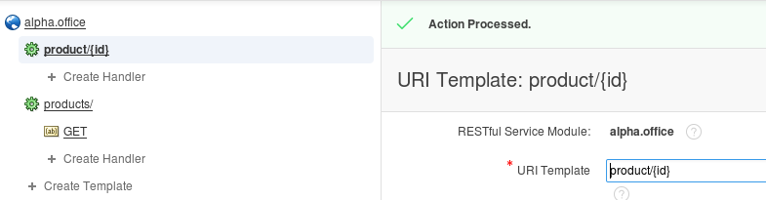

* Enter the following SQL statement in the Source field of the Resource Handler page. Notice the use of the ":id" bind variable, this value comes from the URI template {id} provided when the service is invoked.

**Source:**

select *

from products

where product_id = :id

* Once you’ve finished entering the SQL statement, click the Create button.

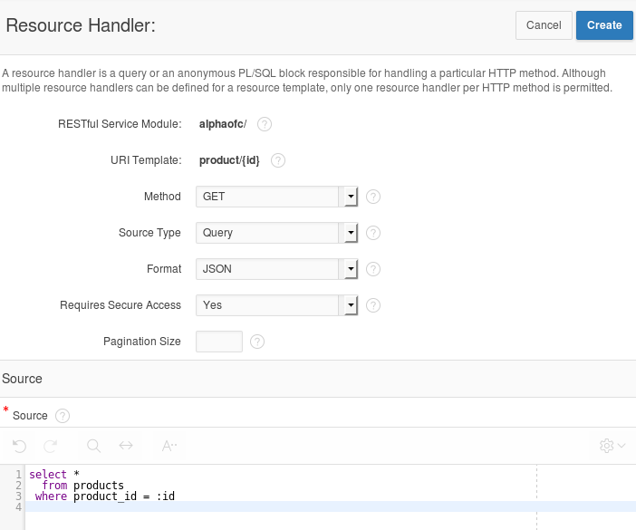

* Notice the ‘Action Processed’ at the top of your screen. We will test this service just like before, but we need to provide a product number to the call.
* Scroll to the bottom of the page and in the Test section, click the Set Bind Variables button.

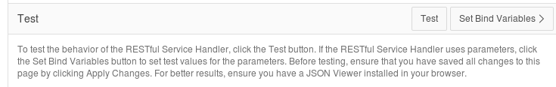

* Enter the following product number and click the **Test** button.

|  |  |
| --- | --- |
| **:ID** | 1020 |

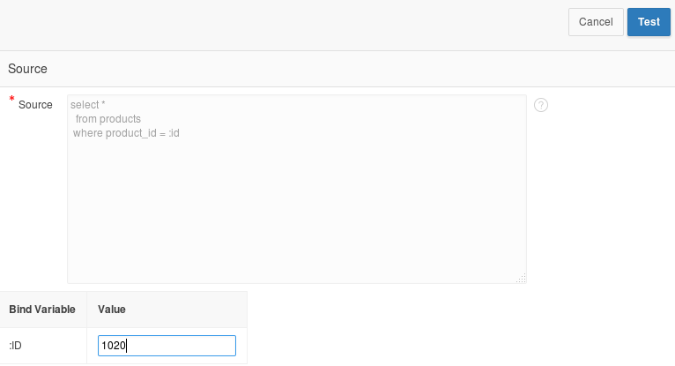

* In the new browser window, notice only the single product shows in the JSON object.
* Close this pop-up window.

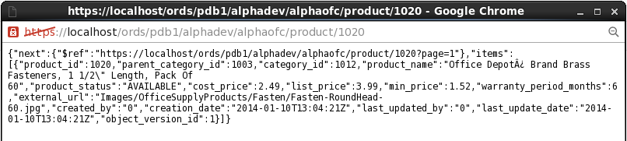

#### Install APEX Mobile Application

* Click the Application Builder menu item on the APEX page.

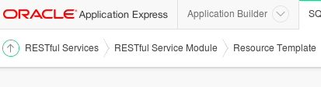

* Click the Import button on the Application Builder page.

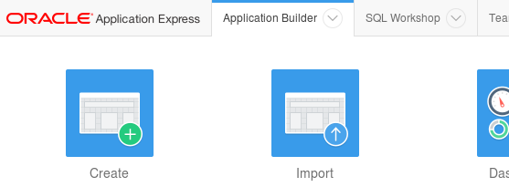

* Click the Browse button to locate the APEX application export file.

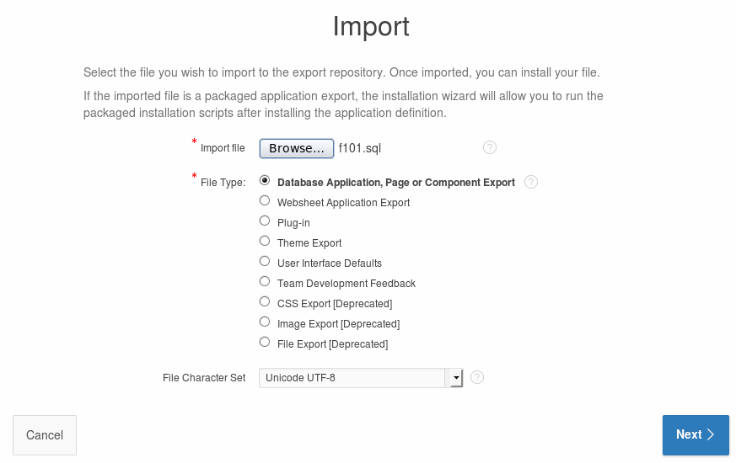

* Locate and open the following file and click the Open button:

**/u01/OPCWorkshop/lab/f101.sql**

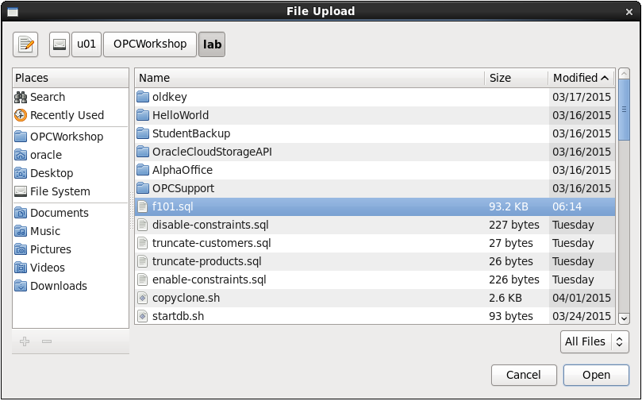

* Click the Next button to continue.



* After a brief pause while the application file is processed, click the Next button to continue.

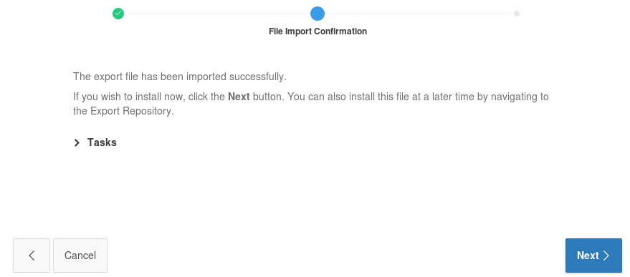

* On the final page, select to Reuse Application ID 101 from Export File
* Click Install Application. 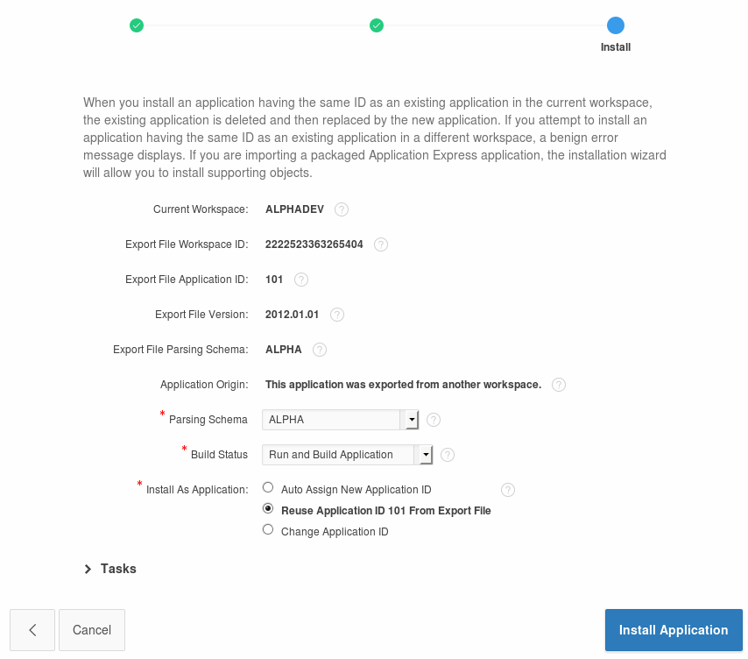
* APEX displays a success message for the import
* Click **Run** Application.

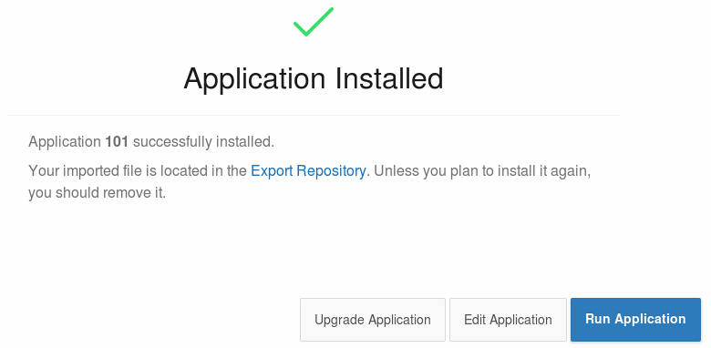

* APEX renders the first page of the mobile application in the browser – it might not look quite right since we are using a mobile template.

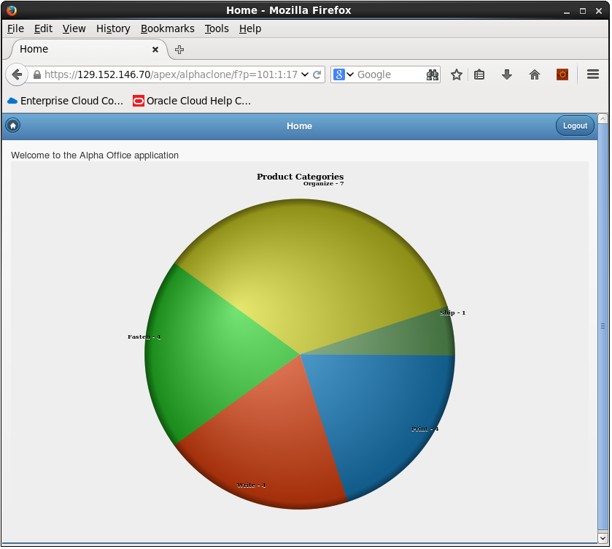

#### Access the Alpha Office Mobile Application on your Smart Device

* Using any Internet connected smart phone or tablet we will access the mobile application using the port we opened earlier in the lab. This example is using an Apple iPhone 5s.
* Use your device's browser and navigate to the following URL:

**https://< Public IP Address of Alpha01A-DBCS>/apex/alphaclone/f?p=101**

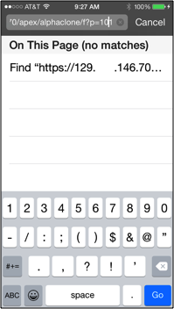

***Note:*** *It may be more convenient to email the link to your device.*

* The browser should prompt you to accept the unknown certificate.
* Click of touch Continue.

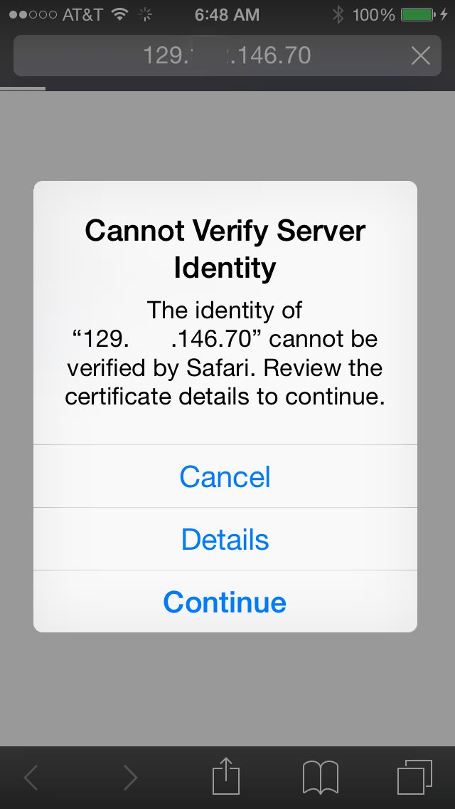

* Touch the screen to explore the application. On the device, touching one of the pie slices highlights the slice; a second tap drills into that slice.

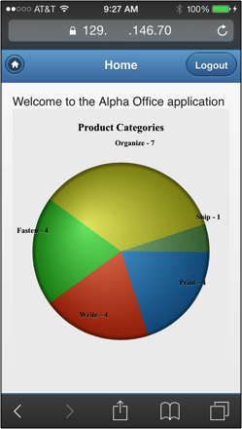

* Congratulations, you’ve created an application on the Oracle Database Cloud. This is the final lab for the DBCS Workshop.